

Bharati Vidyapeeth’s

**Institute of Management & Information Technology**

C.B.D. Belapur, Navi Mumbai 400614

**Vision:**

Providing high quality, innovative and value-based education in information technology to build competent professionals.

**Mission:**

* M1. Technical Skills:--To provide solid technical foundation theoretically as well as Practically capable of providing quality services to multi-disciplinary industry.
* M2. Development: -To provide comprehensive educational programs and promote lifelong learning in the field of Computer Applications based on the changing needs of IT industry and society worldwide.
* M3.Innovation:-To promote innovation and excellence in delivery and assessment to ensure ethical and holistic development of students for employability, entrepreneurship and higher education.
* M4.Ethical leadership: - To develop ethical leadership awareness in the students to succeed in industry, government and academia.

**CERTIFICATE**

This is to certify that the journal is the work of Roll No. of **MCA** (**Sem- 2 Div: B**) for the academic year 2023 - 2024

Subject Code: **MCAL26**

Subject Name: **Networking with Linux Lab**

________________ ______________

Subject-in-charge Principal

Date: _________________

______________________

External Examiner

Date: _______________

**Bharati Vidyapeeth's Institute of Management & Information Technology MCA Semester II AY 2023-24**

**MCAL26: Networking with Linux Lab**

**INDEX**

**Name of Student: MCA SEM II Div: B**

|  |  |  |  |  |  |  |  |  |  |  |
| --- | --- | --- | --- | --- | --- | --- | --- | --- | --- | --- |
| **Sr. No.** | **Date** | **Experiment Name** | **CO** | **PO and PSO** | **Attentiveness(5)** | **Presentation(05)** | **Understanding(10)** | **Attendance(5)** | **Total(25)** | **Sign** |
| 1 |  | Installation and configuration of NetAnim | CO1 | PO1,P02,PO2,PO5,PO7 |  |  |  |  |  |  |
| 2 |  | Installation of WireShark |  |  |  |  |  |  |
| 3 |  | Program to simulate traffic between two nodes. | CO2 | PO1,PO2,PO3,PO4,PO5,PO7,PO11,PSO1,PSO2 |  |  |  |  |  |  |
| 4 |  | Also Animate traffic between two nodes in NetAnim and analyse pcap files using wireshark | CO3 | PO1,PO2,PO3,PO4,PO5,PO7,PO11,PSO1,PSO2 |  |  |  |  |  |  |
| 5 |  | Program to implement a Bus topology (Program to connect two point to point nodes to three csma nodes considering one node as a central node) | CO2 | PO1,PO2,PO3,PO4,PO5,PO7,PO11,PSO1,PSO2 |  |  |  |  |  |  |
| 6 |  | Animate Bus Topology in NetAnim |  |  |  |  |  |  |
| 7 |  | Analyse BUS topology simulation pcap files using wireshark | CO3 | PO1,PO2,PO3,PO4,PO5,PO7,PO11,PSO1,PSO2 |  |  |  |  |  |  |
| 8 |  | Program to simulate star topology | CO2 | PO1,PO2,PO3,PO4,PO5,PO7,PO11,PSO1,PSO2 |  |  |  |  |  |  |
| 9 |  | Animate Star Topology in NetAnim |  |  |  |  |  |  |
| 10 |  | Program to simulate Mesh topology | CO2, CO3 | PO1,PO2,PO3,PO4,PO5,PO7,PO11,PSO1,PSO2 |  |  |  |  |  |  |
| 11 |  | Program to simulate Hybrid topology ( Program to connect Wifi, point to point and csma nodes) | CO4 | PO1,PO2,PO3,PO4,PO5,PO7,PO9,PO11,PSO1,PSO2 |  |  |  |  |  |  |
| 12 |  | Program to simulate UDP client-server | CO2 | PO1,PO2,PO3,PO4,PO5,PO7,PO11,PSO1,PSO2 |  |  |  |  |  |  |
| 13 |  | Program to simulate DHCP server and n clients | CO4 | PO1,PO2,PO3,PO4,PO5,PO7,PO9,PO11,PSO1,PSO2 |  |  |  |  |  |  |
| 14 |  | Program to simulate FTP using TCP protocol | CO2 | PO1,PO2,PO3,PO4,PO5,PO7,PO11,PSO1,PSO2 |  |  |  |  |  |  |
| 15 |  | Program to simulate Three way handshake for TCP connection |  |  |  |  |  |  |
| 16 |  | Analyze the above topology network traffic using WireShark | CO3 | PO1,PO2,PO3,PO4,PO5,PO7,PO11,PSO1,PSO2 |  |  |  |  |  |  |
| 17 |  | Mini Project | CO4 | PO1,PO2,PO3,PO4,PO5,PO7,PO9,PO11,PSO1,PSO2 |  |  |  |  |  |  |

**PRACTICAL**

# INSTALLATION OF NS-3 IN LINUX

**Q. What is ns3 (Network Simulator 3) ?**

* Network simulator is a tool used for simulating the real world network on one computer by writing scripts in C++ or Python.
* Normally if we want to perform experiments, to see how our network works using various parameters.
* We don’t have the required number of computers and routers for making different topologies.
* Even if we have these resources it is very expensive to build such a network for experiment purposes.
* So to overcome these drawbacks we used NS3, which is a discrete event network simulator for the Internet. NS3 helps to create various virtual nodes (i.e., computers in real life) and with the help of various Helper classes it allows us to install devices, internet stacks, applications, etc to our nodes.
* Using NS3 we can create PointToPoint, Wireless, CSMA, etc connections between nodes. PointToPoint connection is the same as a LAN connected between two computers.

**Details of ns-3 architecture STL** - Standard Libraries.

**Core** - No network related code. Only timers, random number generators.

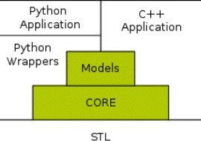**Models** - All network related code.

# Data flow in ns-3

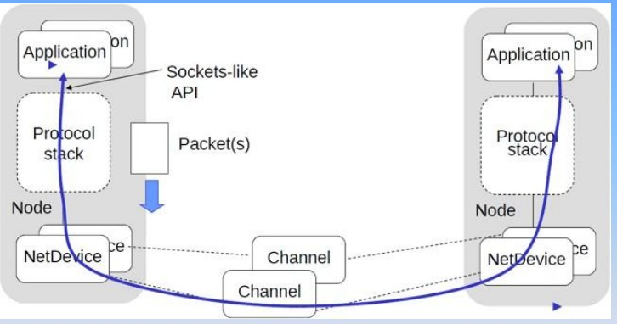

**Installation of NS-3 in Linux**

1. sudo apt upgrade

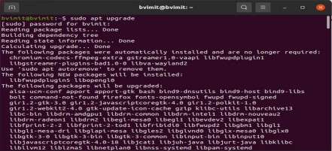

1. sudo apt update

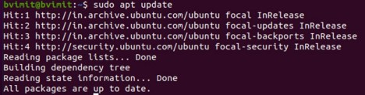

1. Minimal requirements for C++ users sudo apt-get install g++ python3

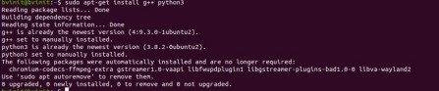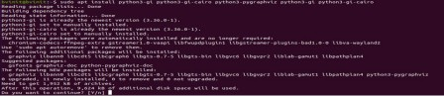

1. Minimal requirements for Python API users

sudo apt-get install g++ python3 python3-dev pkg-config sqlite3

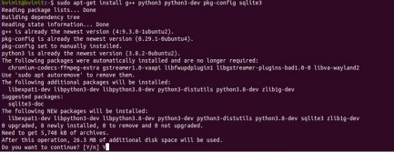

1. Netanim animator: qt5 development tools are needed for Netanim animator; sudo apt-get install qt5-default mercurial

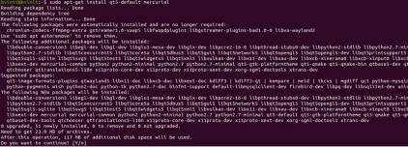

1. ns-3-pyviz visualizer

sudo apt-get install gir1.2-goocanvas-2.0

Sudo apt-get install python3-gi python3-gi-cairo python3-pygraphviz python3-gi python3-gi cairo

sudo apt-get install python3-pygraphviz gir1.2-gtk-3.0 ipython3 ipython3

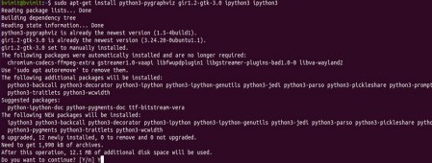

1. Debugging:

sudo apt-get install gdb valgrind

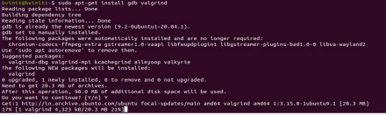

1. Doxygen and related inline documentation:

sudo apt-get install doxygen graphviz imagemagick

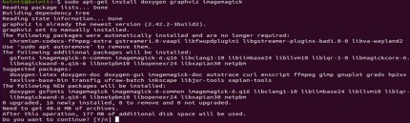

sudo apt-get install texlive texlive-extra-utils texlive-latex-extra texlive-font-utils dvipng latexmk

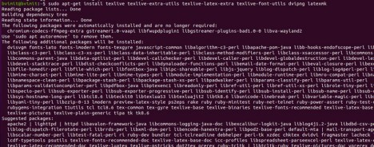

1. The ns-3 manual and tutorial are written in reStructuredText for Sphinx (doc/tutorial, doc/manual, doc/models), and figures typically in dia (also needs the texlive packages above):

sudo apt-get install python3-sphinx dia

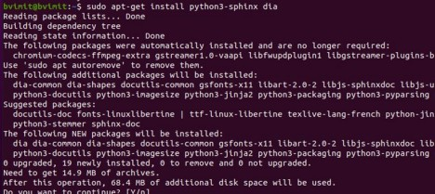

1. To read pcap packet traces sudo apt-get install tcpdump

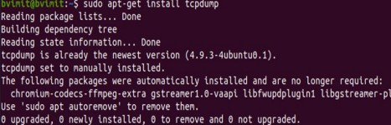

Support for generating modified python bindings

sudo apt-get install cmake libc6-dev libc6-dev-i386 libclang- 6.0-dev llvm-6.0-dev automake python3-pip

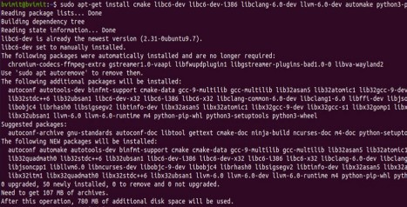

python3 -m pip install --user cxxfilt

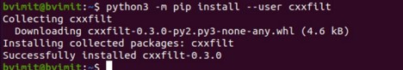

After installing the required packages, create a folder named workspace in the home directory and then put the NS3 tar package into the workspace.

Go to terminal and input these commands consecutively after each command finishes executing: (go to the folder workspace where ns3 is installed)

cd workspace

tarxjf<name of NS3 downloaded file name> (to unzip the file) otherwise you can unzip by right clicking and selecting explore option)

cd<name of extracted NS3>

// go to the ns3allinone folder bvimit@bvimit:~/workspace/ns-allinone-3.32$

/build.py --enable-examples –enable-tests

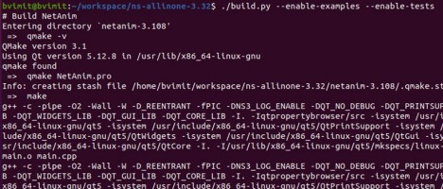

Test the NS3 build and installation success by running test.py in the ns directory using the following commands:

cd ns-<version number> //go to the folder // ns3 folder in ns3allinone

bvimit@bvimit:~/workspace/ns-allinone-3.32/ns-3.32$ then type, ./test.py

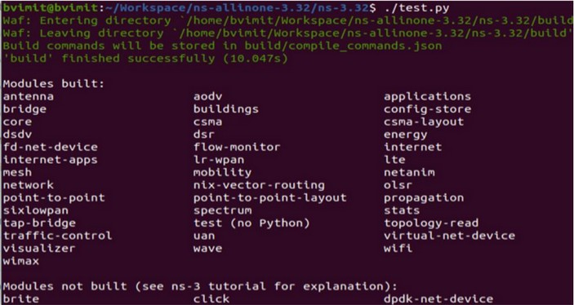

./waf --run hello-simulator

This will display "Hello Simulator" Which indicates that ns3 is installed successfully.

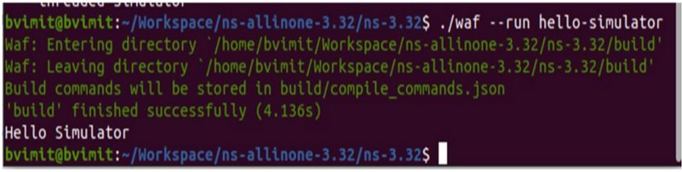

# PRACTICAL NO 1

**INSTALLATION OF NETANIM**

# What is NetAnim?

NetAnim is an offline animator based on the Qt toolkit. It animates a previously executed simulation using an XML trace file generated during a simulation. The first version was developed by George F Riley.

The current version was largely developed by John Abraham. NetAnim has not been actively maintained/improved since 2017.

NetAnim is an offline network animator tool that now ships along with the ns-allinone-3.xx package.

It can animate the ns-3 network simulation using an XML trace file that is generated as an output during simulation.

So, the necessary steps for creating this XML trace file and setting its related attributes should be done in the ns-3 simulation code itself.

# Why use NetAnim?

NetAnim makes executing simulations more interesting. It allows you to visualize the entire simulation execution in a bird's eye view in terms of inspecting a variety of nodes, their configuration details, placement models, mobility models, and packet flows.

# What is the Role of NetAnim in Ns3 Simulator How do I Enable NetAnim?

NetAnim in Ns3

In general, netanim is considered as the standalone and Qt4 based software which is implementable through the utilization of the trace file that is generated while the process of ns-3 simulation to depict the topology and animate the packet flow among the nodes.

# Installation of NetAnim

Step1: Open terminal and type sudo apt upgrade .

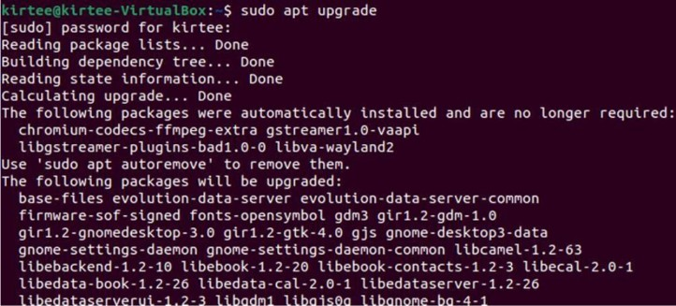

Step 2: sudo apt update

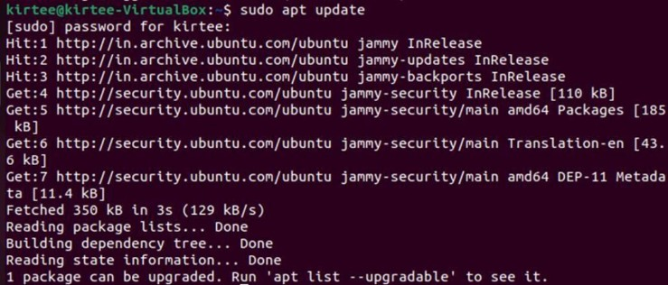

Step 3: sudo ./waf configure

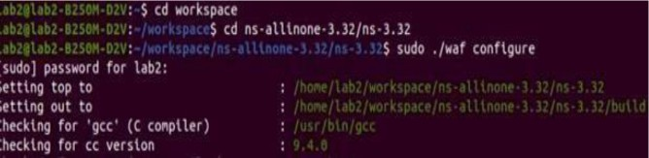

Step 4: sudo ./waf build

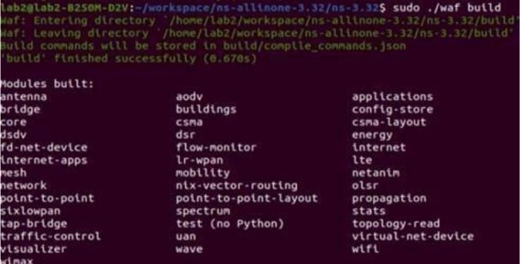

Step 5: cd netanim-3.108 & ls

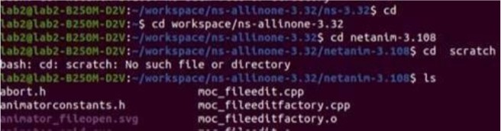

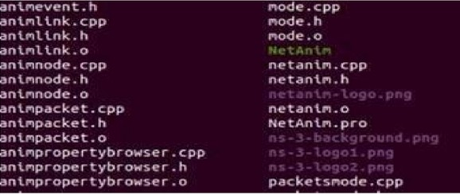

Step 6: ./NetAnim



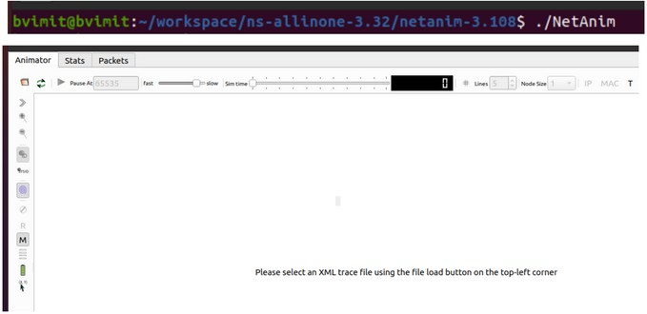Successfully the NetAnim will be installed Step 7:- ./NetAnim

Open the folder->ns-3.32->first.xml.

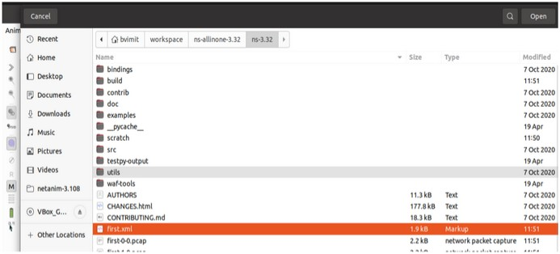

Then Start the simulation

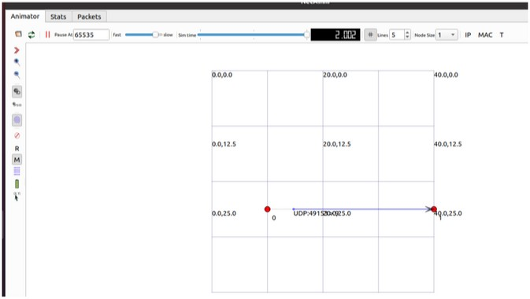

# PRACTICAL NO 2

**INSTALLATION OF WIRESHARK**

# What is WireShark?

Wireshark is a network protocol analyzer, or an application that captures packets from a network connection, such as from your computer to your home office or the internet. Packet is the name given to a discrete unit of data in a typical Ethernet network.

Wireshark is the most often-used packet sniffer in the world. Like any other packet sniffer, Wireshark does three things:

* 1. Packet Capture: Wireshark listens to a network connection in real time and then grabs entire streams of traffic – quite possibly tens of thousands of packets at a time.
  2. Filtering: Wireshark is capable of slicing and dicing all of this random live data using filters. By applying a filter, you can obtain just the information you need to see.
  3. Visualization: Wireshark, like any good packet sniffer, allows you to dive right into the very middle of a network packet. It also allows you to visualize entire conversations and network streams.

# What Is Wireshark Used For?

Wireshark has many uses, including troubleshooting networks that have performance issues. Cybersecurity professionals often use Wireshark to trace connections, view the contents of suspect network transactions and identify bursts of network traffic. It’s a major part of any IT pro’s toolkit – and hopefully, the IT pro has the knowledge to use it.

# When Should Wireshark Be Used?

Wireshark is a safe tool used by government agencies, educational institutions, corporations, small businesses and nonprofits alike to troubleshoot network issues. Additionally, Wireshark can be used as a learning tool.

Those new to information security can use Wireshark as a tool to understand network traffic analysis, how communication takes place when particular protocols are involved and where it goes wrong when certain issues occur.

# Installation of WireShark

**For Linux:**

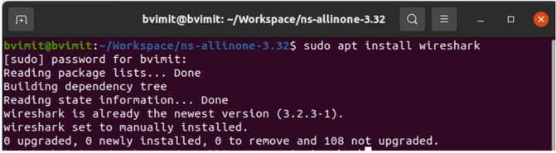Open Terminal and type the command sudo apt install wireshark

Then again type wireshark in terminal then directly it will open the wireshark

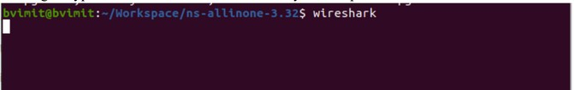

When wireshark open then file->open->Go to ns-3.2 and open the first-0-0.pcap folder

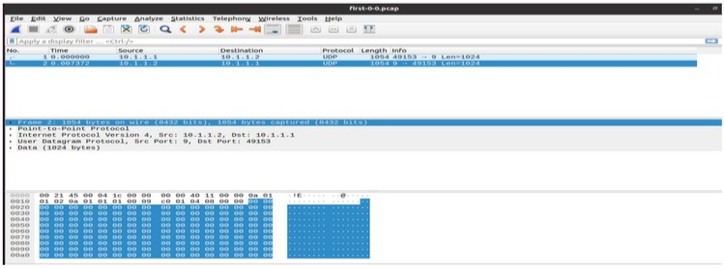

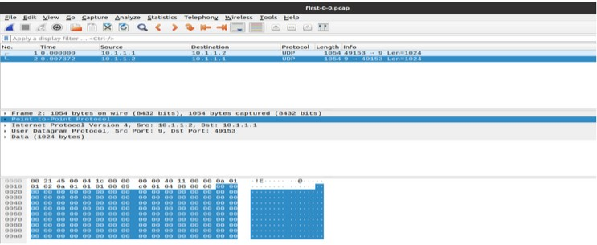

# For Windows:

Step 1: download latest version of Wireshark on your windows operating system.

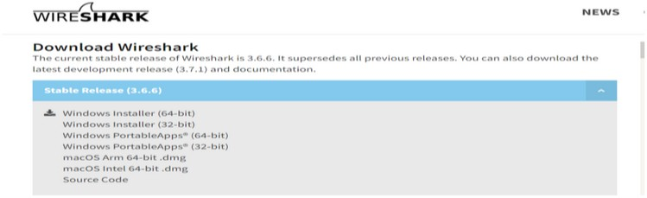

Step 2: Install Wireshark on your system.

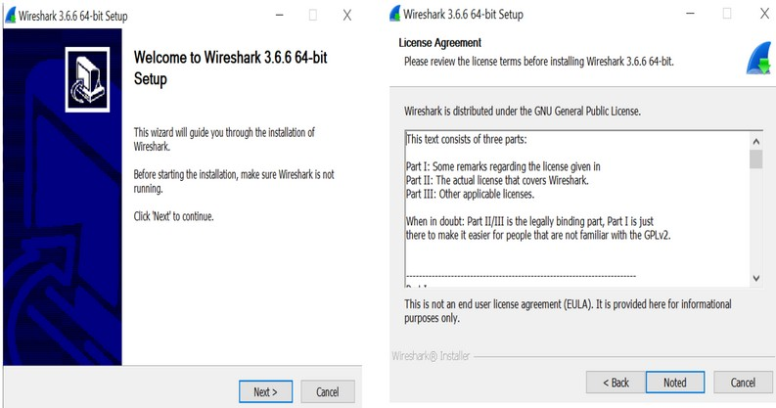

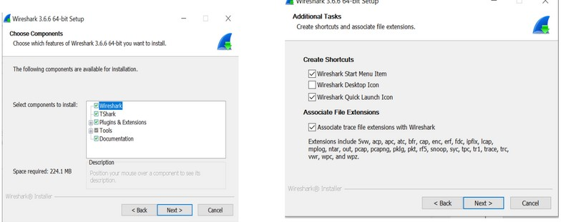

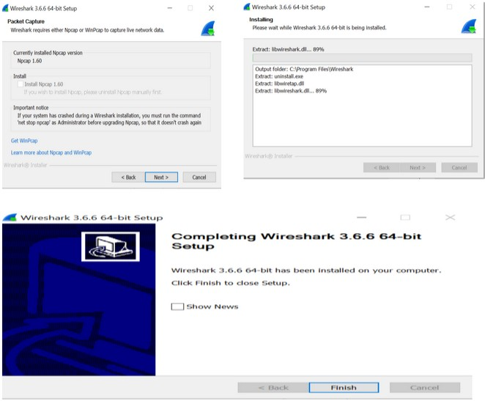

Wireshark is successfully installed on your window system.

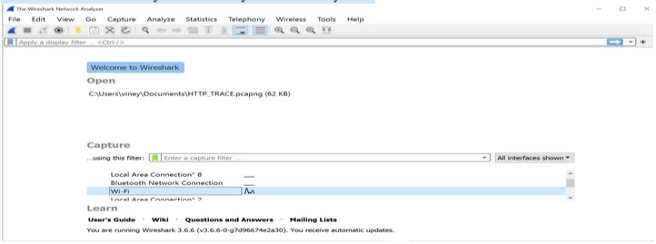

# PRACTICAL NO 3

**PROGRAM TO SIMULATE TRAFFIC BETWEEN TWO NODES**

# Using Visualization first.cc

**Code:-**

//pre defined modules #include "ns3/core-module.h"

#include "ns3/network-module.h" #include "ns3/internet-module.h" #include "ns3/point-to-point-module.h" #include "ns3/applications-module.h"

// Default Network Topology

//

// 10.1.1.0

// n0 n1

// point-to-point

//

//The ns-3 project is implemented in a C++ namespace called ns3. This groups all ns-3-related declarations in a scope outside the global namespace, which will help with integration with other code.

using namespace ns3;

//Enable the log for this program.This line declares a logging component called FirstScriptExample that allows you to enable and disable console message logging by reference to the name.

NS_LOG_COMPONENT_DEFINE ("FirstScriptExample");

//It is just the declaration of the main function of your program (script).

int

main (int argc, char *argv[])

{

//This command is used to read and parse command line argument.

CommandLine cmd ( FILE ); cmd.Parse (argc, argv); Time::SetResolution (Time::NS);

//These two lines of the script are used to enable two logging components that are built into the Echo Client and Echo Server applications:

LogComponentEnable ("UdpEchoClientApplication", LOG_LEVEL_INFO); LogComponentEnable ("UdpEchoServerApplication", LOG_LEVEL_INFO);

//The NodeContainer topology helper provides a convenient way to create, manage and access any Node objects that we create in order to run a simulation. The first line above just declares a NodeContainer which we call nodes. The second line calls the Create method on the nodes object and asks the container to create two nodes

NodeContainer nodes; nodes.Create (2);

// It instantiates a PointToPointHelper object on the stack.

PointToPointHelper pointToPoint;

//It tells the PointToPointHelper object to use the value “5Mbps” (five megabits per second) as the “DataRate” when it creates a PointToPointNetDevice object.

pointToPoint.SetDeviceAttribute ("DataRate", StringValue ("5Mbps"));

//It tells the PointToPointHelper to use the value “2ms” (two milliseconds) as the value of the transmission delay of every point to point channel it subsequently creates.

pointToPoint.SetChannelAttribute ("Delay", StringValue ("2ms"));

// This line declares the device container object.

NetDeviceContainer devices;

//The Install method of the PointToPointHelper takes a NodeContainer as a parameter. Internally, a NetDeviceContainer is created.

devices = pointToPoint.Install (nodes);

//The InternetStackHelper is a topology helper that is to internet stacks what the PointToPointHelper is to point-to-point net devices. The Install method takes a NodeContainer as a parameter. When it is executed, it will install an Internet Stack (TCP, UDP, IP, etc.) on each of the nodes in the node container.

InternetStackHelper stack; stack.Install (nodes);

//It declare an address helper object and tell it that it should begin allocating IP addresses from the network

10.1.1.0 using the mask 255.255.255.0 to define the allocatable bits. By default the addresses allocated will start at one and increase monotonically, so the first address allocated

from this base will be 10.1.1.1, followed by 10.1.1.2, etc.

Ipv4AddressHelper address;

address.SetBase ("10.1.1.0", "255.255.255.0");

//It performs the actual address assignment.

Ipv4InterfaceContainer interfaces = address.Assign (devices);

//Set up a UDP echo server application on one of the nodes we have previously created.

//Declares the UdpEchoServerHelper at port 9

UdpEchoServerHelper echoServer (9);

//This method actually causes the underlying echo server application to be instantiated and attached to a node.

ApplicationContainer serverApps = echoServer.Install (nodes.Get (1));

//Define the start time of server.

serverApps.Start (Seconds (1.0));

//Define the stop time of server.

serverApps.Stop (Seconds (10.0));

//Set up a UDP echo client application on one of the nodes we have previously created.

The first two Attributes are set during construction of the UdpEchoClientHelper. We pass parameters that are used (internally to the helper) to set the “RemoteAddress” and “RemotePort”

Attributes.

UdpEchoClientHelper echoClient (interfaces.GetAddress (1), 9);

//The “MaxPackets” Attribute tells the client the maximum number of packets we allow it to send during the simulation.

echoClient.SetAttribute ("MaxPackets", UintegerValue (1));

//The “Interval” Attribute tells the client how long to wait between packets, and the “PacketSize” Attribute tells the client how large its packet payloads should be. With this particular combination of Attributes, we are telling the client to send one 1024-byte packet.

echoClient.SetAttribute ("Interval", TimeValue (Seconds (1.0)));

echoClient.SetAttribute ("PacketSize", UintegerValue (1024));

//This method actually causes the underlying echo client application to be instantiated.

ApplicationContainer clientApps = echoClient.Install (nodes.Get (0));

//This define the start time.

clientApps.Start (Seconds (2.0));

//This define the stop time.

clientApps.Stop (Seconds (10.0));

//run the simulation.

Simulator::Run ();

//destroy all of the objects that were created.

Simulator::Destroy (); return 0;

}

Steps:

Write the commands in terminal given below

Put first.cc in scratch folder.

-> ./waf –run scratch/first For Visualization

-> .waf –run scratch/first –vis

# OUTPUT:

1. ./waf --run scratch/first

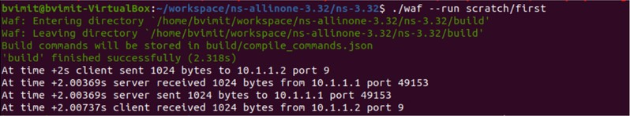

1. ./waf --run scratch/first --vis

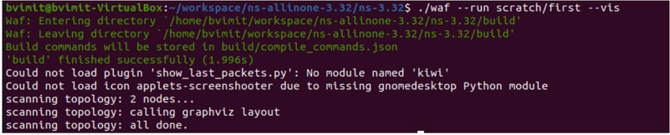

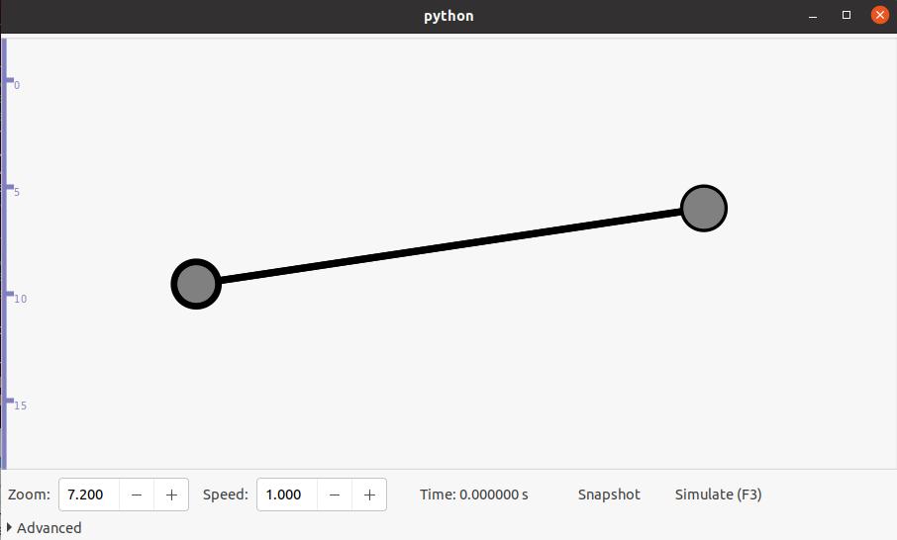

# PRACTICAL NO 4

**ANIMATE TRAFFIC BETWEEN TWO NODES IN NETANIM AND ANALYZE PCAP FILES USING WIRESHARK**

# Q. What is Point-to-point Topology?

Point to Point (P2P) topology is a network topology that connects two nodes or devices (hub, router, switch, etc.) directly using a private, dedicated line (LAN cable). In this topology, one of the connected nodes serves as the transmitter, while the other acts as the receiver.

This topology is considered the simplest and most cost-effective way of creating a computer network because it requires only a single communication channel between the two connected nodes. Apart from that, this topology reserves the entire bandwidth of the connection for communication, minimizing the chances of congestion and providing a more reliable connection.

# Examples of Point to Point Topology

Here are some examples of this topology:

* Bluetooth file transfer between two devices
* Direct cable connection between two computers
* Fax machine transmitting data to another fax machine
* Dedicated phone line connection between two modems
* Satellite Communication link between two ground stations

# Advantages of P2P Topology:

* + Point to Point topology provides a dedicated communication channel between two nodes, ensuring faster data transfer rates.
  + Since only two devices are connected, identifying and troubleshooting issues is simpler than any other network topology, as each node or connection can be tested individually.
  + P2P topology offers increased security as data is transmitted directly between two nodes, reducing the chances of data interception or theft.

# Disadvantages of P2P Topology:

* + With P2P networks, adding new devices means establishing a separate link between each new device and the existing network, which can be time-consuming and expensive.
  + When a link fails, or a device goes offline, it can cause problems as there are no alternative routes through which data can be transmitted.
  + P2P topology is unsuitable for large areas due to the need for a direct connection.

# Diagram

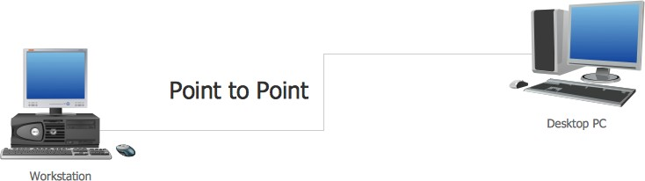

**Animate traffic between two nodes in NetAnim and analyse pcap files using wireshark File Name:-animation.cc**

# Code:-

#include "ns3/core-module.h" #include "ns3/network-module.h" #include "ns3/internet-module.h"

#include "ns3/point-to-point-module.h" #include "ns3/applications-module.h"

//netanimation

#include "ns3/netanim-module.h" #include "ns3/mobility-module.h"

using namespace ns3;

NS_LOG_COMPONENT_DEFINE ("FirstScriptExample");

int

main (int argc, char *argv[])

{

CommandLine cmd ( FILE ); cmd.Parse (argc, argv);

LogComponentEnable ("UdpEchoClientApplication", LOG_LEVEL_INFO); LogComponentEnable ("UdpEchoServerApplication", LOG_LEVEL_INFO);

NodeContainer nodes; nodes.Create (2);

PointToPointHelper pointToPoint;

pointToPoint.SetDeviceAttribute ("DataRate", StringValue ("5Mbps")); pointToPoint.SetChannelAttribute ("Delay", StringValue ("2ms"));

NetDeviceContainer devices; devices= pointToPoint.Install (nodes);

InternetStackHelper stack; stack.Install (nodes);

Ipv4AddressHelper address;

address.SetBase ("10.1.1.0", "255.255.255.0");

Ipv4InterfaceContainer interfaces = address.Assign (devices);

UdpEchoServerHelper echoServer (9);

ApplicationContainer serverApps = echoServer.Install (nodes.Get (1)); serverApps.Start(Seconds(1.0));

serverApps.Stop (Seconds (10.0));

UdpEchoClientHelper echoClient (interfaces.GetAddress (1), 9); echoClient.SetAttribute ("MaxPackets", UintegerValue (1));

echoClient.SetAttribute ("Interval", TimeValue (Seconds (1.0))); echoClient.SetAttribute ("PacketSize", UintegerValue (1024));

ApplicationContainer clientApps = echoClient.Install (nodes.Get (0)); clientApps.Start (Seconds (2.0));

clientApps.Stop (Seconds (10.0));

MobilityHelper mobility; mobility.SetMobilityModel("ns3::ConstantPositionMobilityModel"); mobility.Install(nodes);

AnimationInterface anim("first.xml"); AnimationInterface::SetConstantPosition (nodes.Get(0), 10, 25);

AnimationInterface::SetConstantPosition (nodes.Get(1), 40, 25);

anim.EnablePacketMetadata(true); pointToPoint.EnablePcapAll("first");

Simulator::Run (); Simulator::Destroy (); return 0;

}

OUTPUT:

1. ./waf --run scratch/first

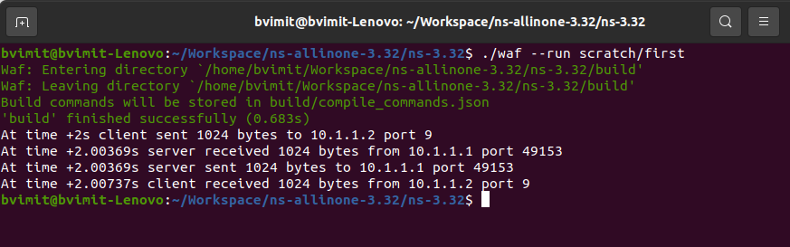

1. ls *.xml

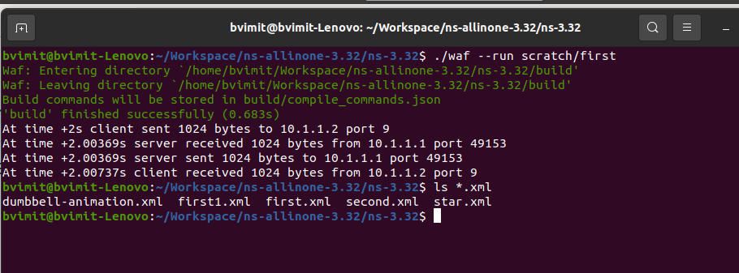



The first.xml file is created in the ns-3.32 folder

1. ./NetAnim



Open the folder->ns-3.32->first.xml.

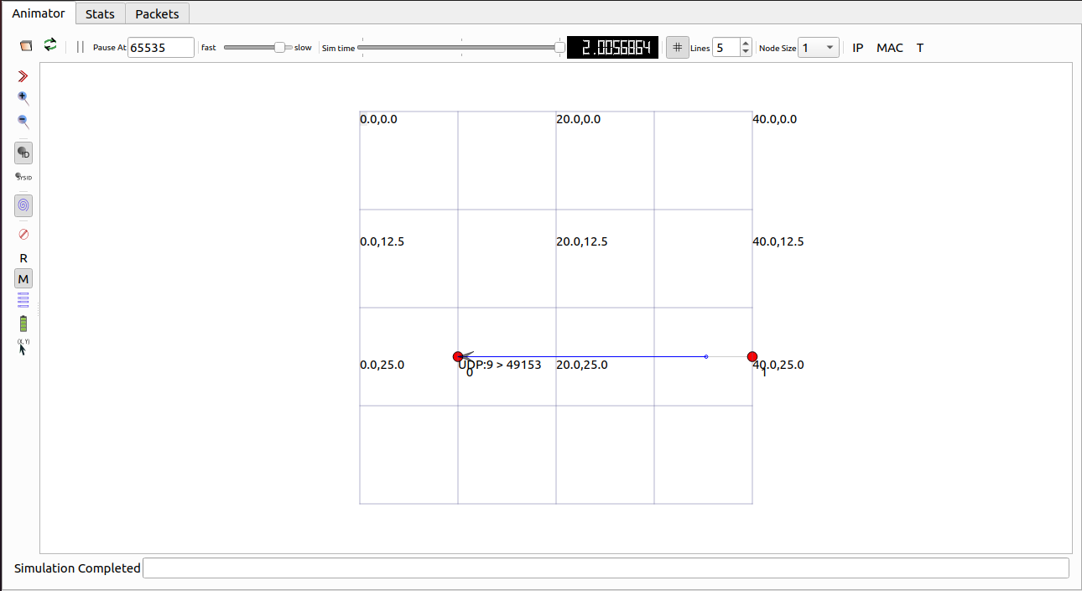

Analyse the Pcap files using wireshark

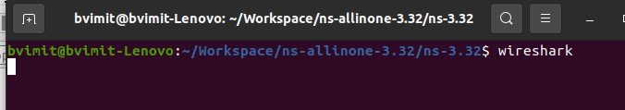

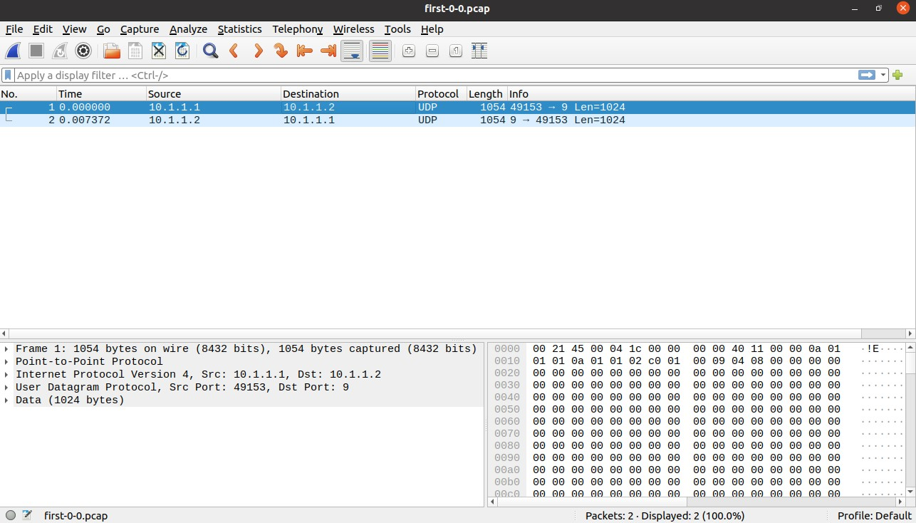

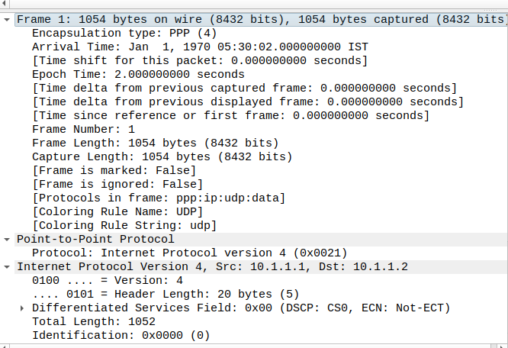

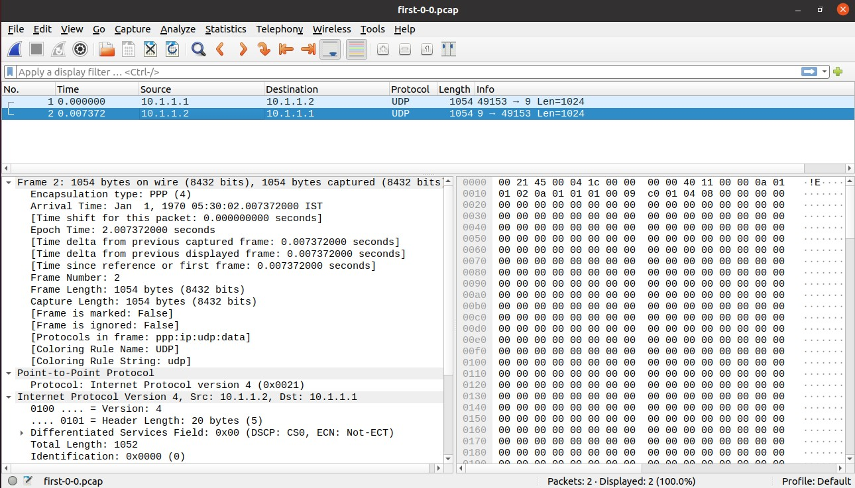

# PRACTICAL NO 5

**PROGRAM TO IMPLEMENT A BUS TOPOLOGY.**

# What is Bus Topology?

* + Bus topology is a network type in which every computer and network device is connected to a single cable.
  + It transmits the data from one end to another in a single direction.
  + No bi-directional feature is in bus topology.
  + It is a multi-point connection and a non-robust topology because if the backbone fails the topology crashes.

The backbone cable is considered as a "single lane" through which the message is broadcast to all the stations.

# Diagram

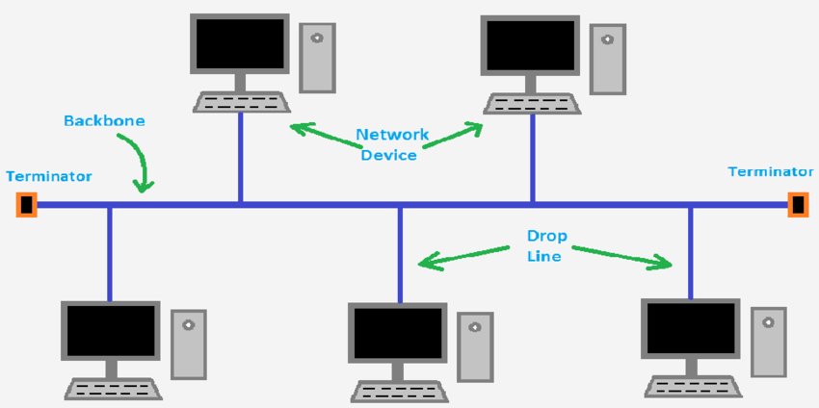

A bus topology with shared backbone cable. The nodes are connected to the channel via drop lines.

# Advantages of this topology :

* + If N devices are connected to each other in a bus topology, then the number of cables required to connect them is 1, which is known as backbone cable, and N drop lines are required.
  + The cost of the cable is less as compared to other topologies, but it is used to build small networks.

# Disadvantages of this topology:

* + - It can be difficult to identify the problems if the whole network goes down.
    - It can be hard to troubleshoot individual device issues.
    - Bus topology is not great for large networks.
    - Terminators are required for both ends of the main cable.
    - Additional devices slow the network down.
    - If a main cable is damaged, the network fails or splits into Applications of Bus Topology

# Program to implement Bus Topology.

**Code:**

//Include Necessary Header Files #include "ns3/core-module.h" #include "ns3/network-module.h" #include "ns3/csma-module.h" #include "ns3/internet-module.h"

#include "ns3/point-to-point-module.h" #include "ns3/applications-module.h" #include "ns3/ipv4-global-routing-helper.h"

//net animation

#include "ns3/netanim-module.h" #include "ns3/mobility-module.h"

//use ns3 namespace using namespace ns3;

//Enable log for this program NS_LOG_COMPONENT_DEFINE ("SecondScriptExample");

int

main (int argc, char *argv[])

{

bool verbose = true; uint32_t nCsma = 3;

CommandLine cmd ( FILE );

cmd.AddValue ("nCsma", "Number of \"extra\" CSMA nodes/devices", nCsma); cmd.AddValue ("verbose", "Tell echo applications to log if true", verbose);

cmd.Parse (argc,argv);

if (verbose)

{

LogComponentEnable ("UdpEchoClientApplication", LOG_LEVEL_INFO); LogComponentEnable ("UdpEchoServerApplication", LOG_LEVEL_INFO);

}

nCsma = nCsma == 0 ? 1 : nCsma;

NodeContainer p2pNodes; p2pNodes.Create (2);

NodeContainer csmaNodes; csmaNodes.Add (p2pNodes.Get (1)); csmaNodes.Create (nCsma);

PointToPointHelper pointToPoint;

pointToPoint.SetDeviceAttribute ("DataRate", StringValue ("5Mbps")); pointToPoint.SetChannelAttribute ("Delay", StringValue ("2ms"));

NetDeviceContainer p2pDevices;

p2pDevices = pointToPoint.Install (p2pNodes);

CsmaHelper csma;

csma.SetChannelAttribute ("DataRate", StringValue ("100Mbps")); csma.SetChannelAttribute ("Delay", TimeValue (NanoSeconds (6500)));

NetDeviceContainer csmaDevices; csmaDevices = csma.Install (csmaNodes);

InternetStackHelper stack; stack.Install (p2pNodes.Get (0)); stack.Install (csmaNodes);

Ipv4AddressHelper address;

address.SetBase ("10.1.1.0", "255.255.255.0");

Ipv4InterfaceContainer p2pInterfaces; p2pInterfaces = address.Assign (p2pDevices);

address.SetBase ("10.1.2.0", "255.255.255.0");

Ipv4InterfaceContainer csmaInterfaces; csmaInterfaces = address.Assign (csmaDevices);

UdpEchoServerHelper echoServer (9);

ApplicationContainer serverApps = echoServer.Install (csmaNodes.Get (nCsma)); serverApps.Start (Seconds (1.0));

serverApps.Stop (Seconds (10.0));

UdpEchoClientHelper echoClient (csmaInterfaces.GetAddress (nCsma), 9); echoClient.SetAttribute ("MaxPackets", UintegerValue (1)); echoClient.SetAttribute ("Interval", TimeValue (Seconds (1.0))); echoClient.SetAttribute ("PacketSize", UintegerValue (1024));

ApplicationContainer clientApps = echoClient.Install (p2pNodes.Get (0)); clientApps.Start (Seconds (2.0));

clientApps.Stop (Seconds (10.0));

Ipv4GlobalRoutingHelper::PopulateRoutingTables ();

pointToPoint.EnablePcapAll ("second"); csma.EnablePcap ("second", csmaDevices.Get (1), true);

// For Net Anim

MobilityHelper mobility; mobility.SetMobilityModel("ns3::ConstantPositionMobilityModel"); mobility.Install(p2pNodes);

mobility.Install(csmaNodes);

AnimationInterface anim("secondtutorial.xml"); AnimationInterface::SetConstantPosition (p2pNodes.Get(0),10, 25);

AnimationInterface::SetConstantPosition (p2pNodes.Get(1), 20, 25);

AnimationInterface::SetConstantPosition(csmaNodes.Get(1), 40, 25);

AnimationInterface::SetConstantPosition(csmaNodes.Get(2), 50, 25);

AnimationInterface::SetConstantPosition(csmaNodes.Get(3), 60,25);

Simulator::Run (); Simulator::Destroy ();

return 0;

}

# OUTPUT:

1. ./waf --run scratch/bustopo

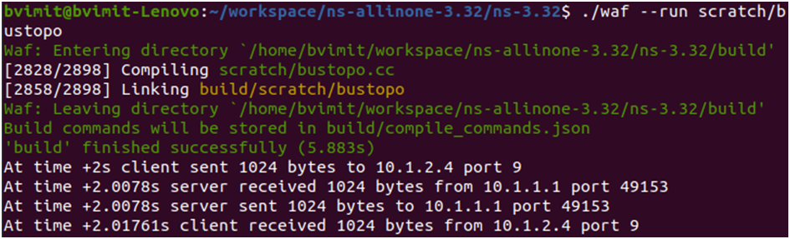

1. ./waf –run scratch/bustopo –vis

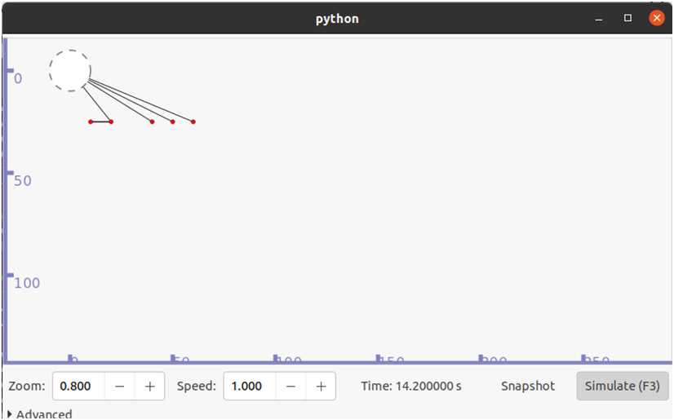

# PRACTICAL NO 6

**ANIMATE BUS TOPOLOGY IN NETANIM.**

To animate the bus topology using below command

Open the command line with path of netAnim store folder

* 1. ./NetAnim

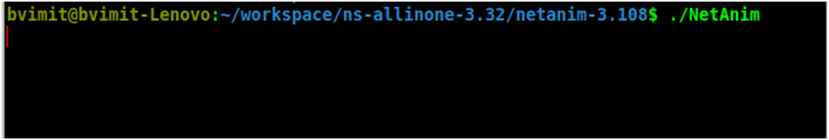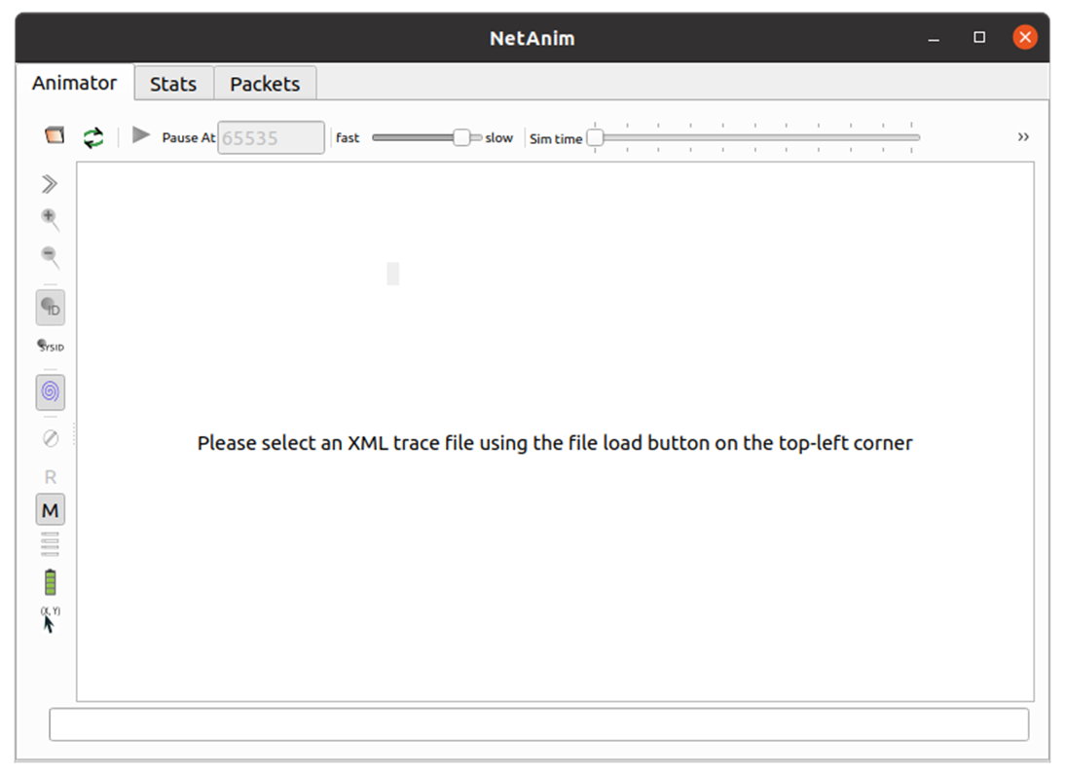

Now provide the xml file to netanim which is created on execution of code to animate.

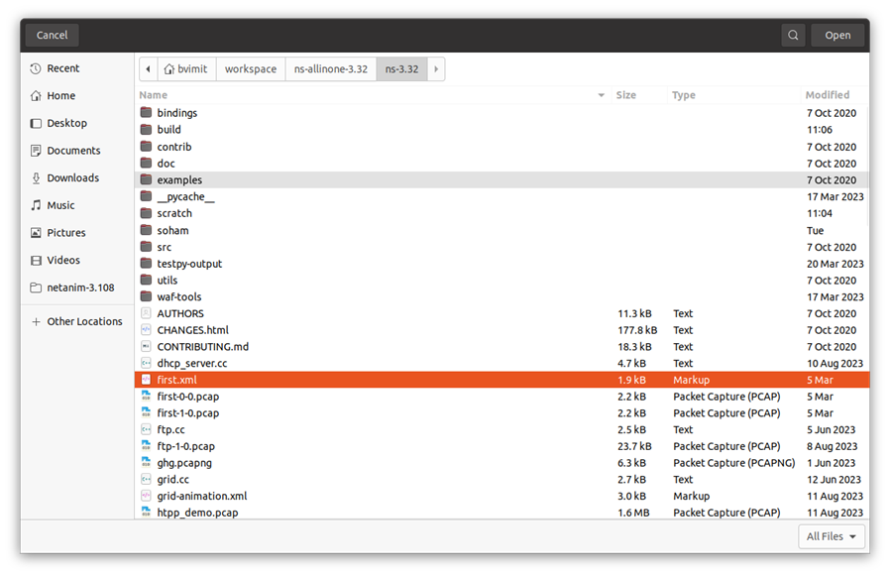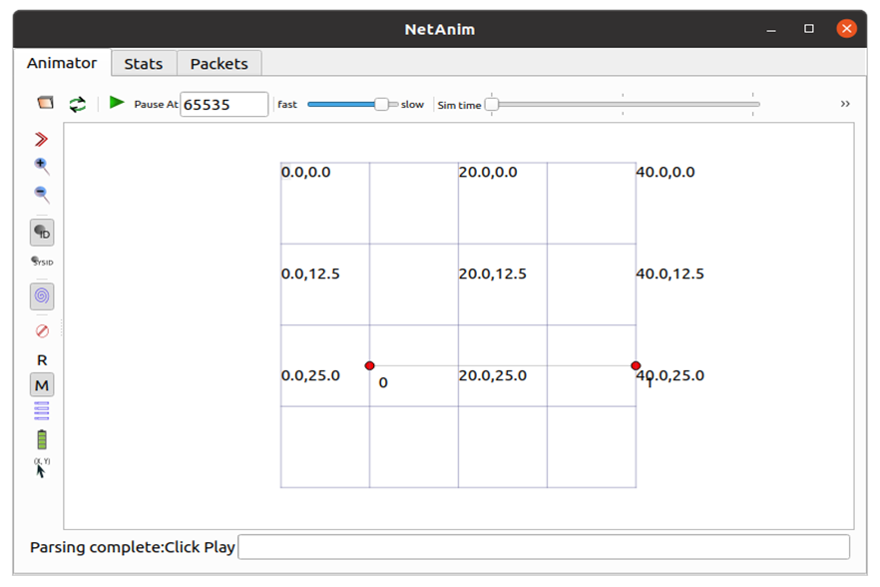

Click over run button to start animation of the bus topology.

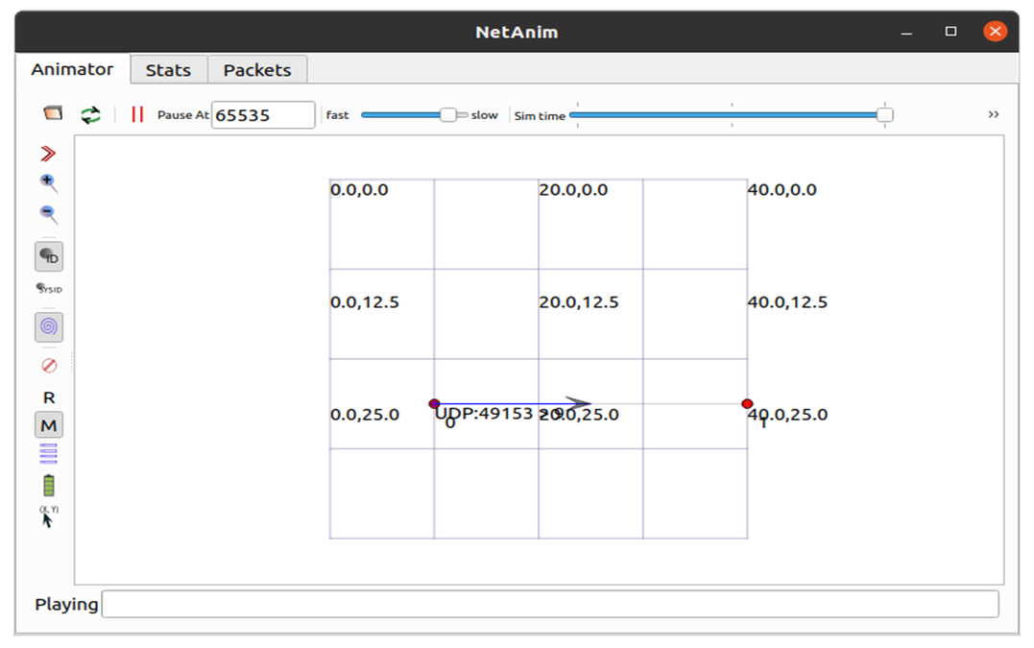

# PRACTICAL NO 7

**ANALYSE BUS TOPOLOGY SIMULATION PCAP FILES USING WIRESHARK.**

Now Using Wireshark we will demonstrate the packet tracing between two nodes.

1. We require a pcap file for wireshark tracing which has created on running the busTopo.cc as with first-1-0.pcap

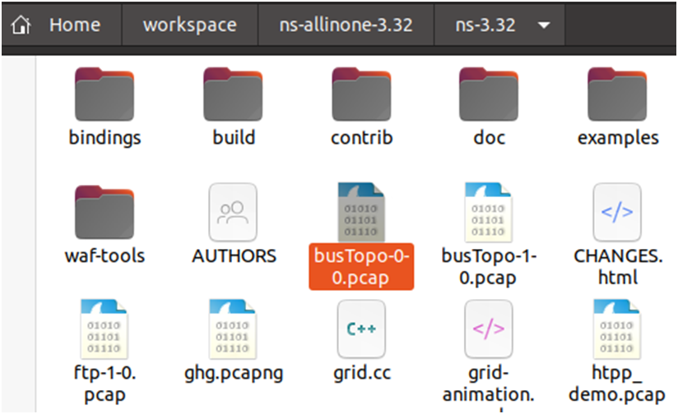

1. 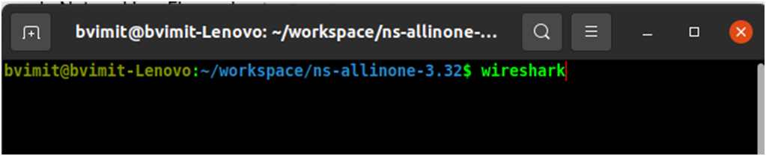Open terminal in path /workspace/ns-allinone-3.32 Run command Wireshark.

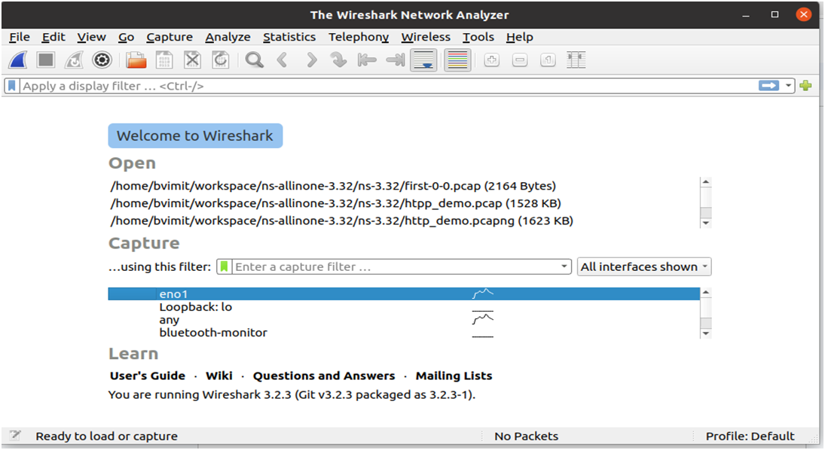

1. 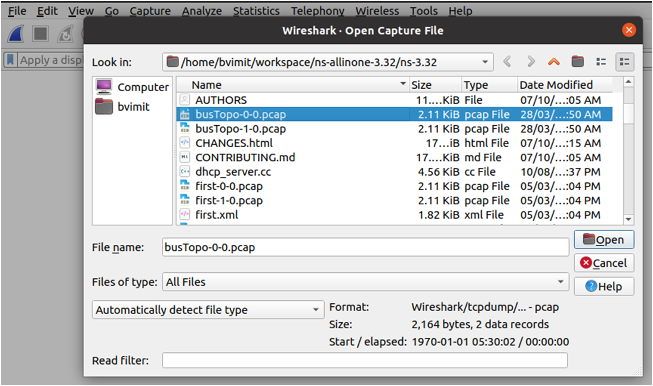Now open the first-1-0.pcap in wireshark.

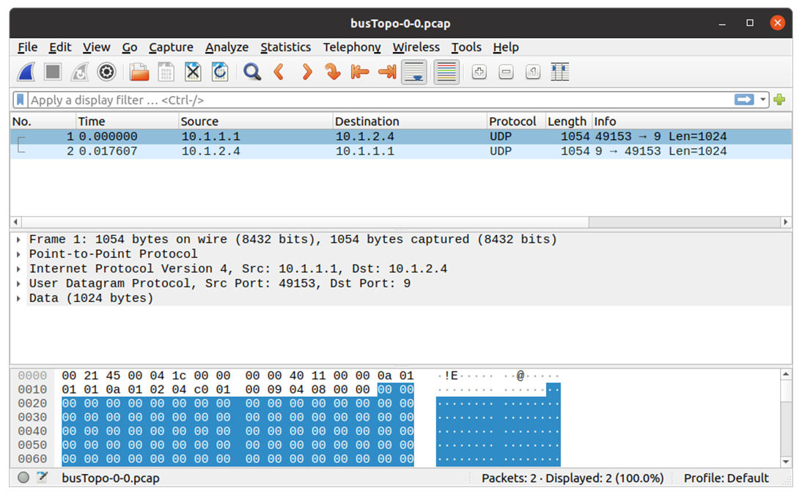

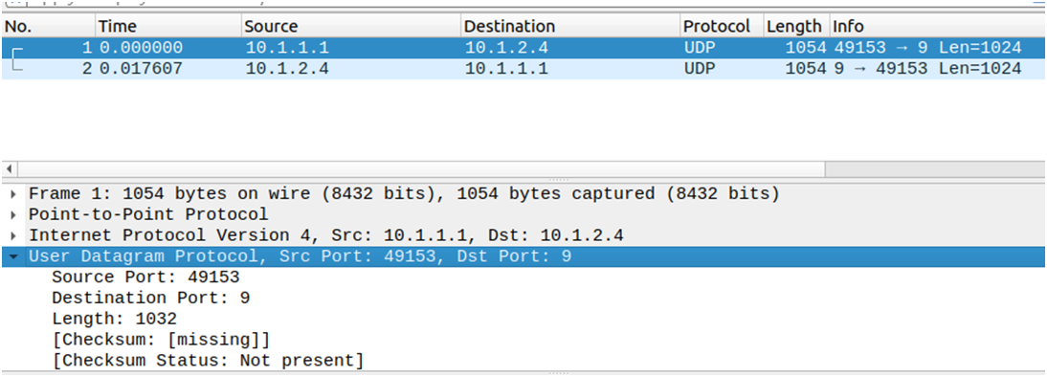

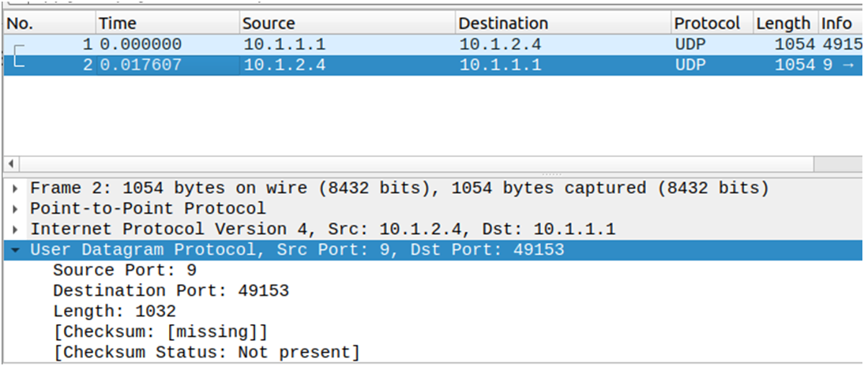

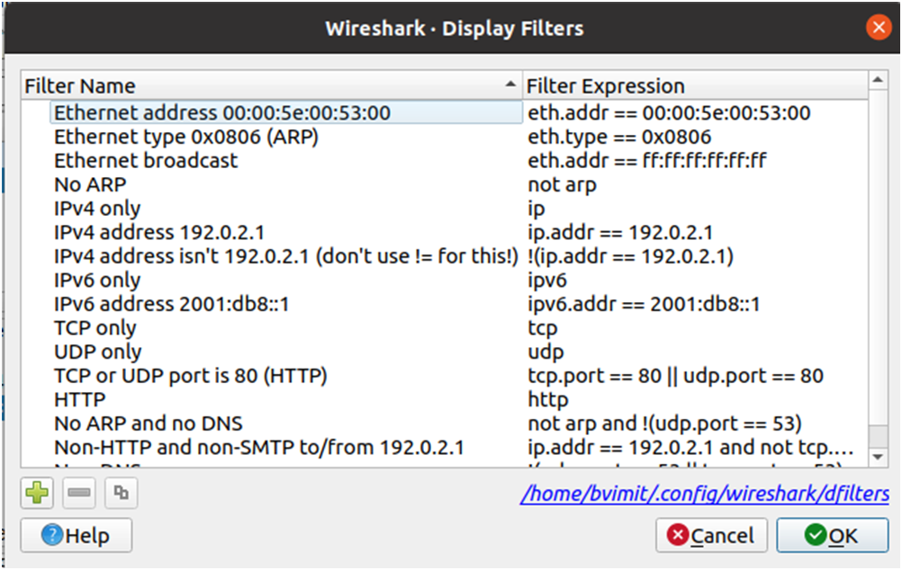

From Above tracing we come to know the Protocol we have used for sending and receiving packets i.e UDP using busTopology with IPV4 and also we can see that the sender, receiver IP and PORT over which they are communicating.

**PRACTICAL NO 8**

**PROGRAM TO SIMULATE STAR TOPOLOGY**

**What is a Star Topology?**

A Star topology is a type of network topology in which all the devices or nodes are physically connected to a central node such as a router, switch, or hub. The central node (hub) acts as a server, and the connecting nodes act as clients.

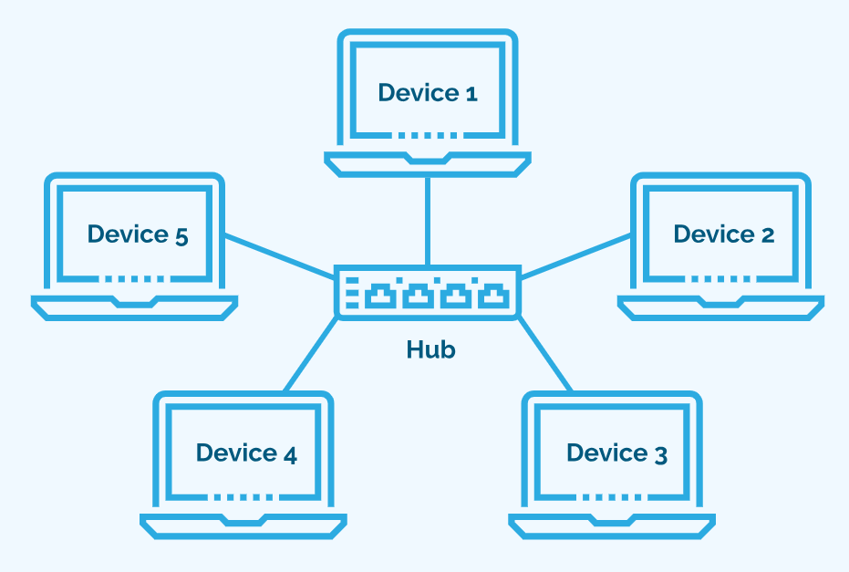

**How Does Star Topology in Computer Network Work?**

In Star topology, a central device is responsible for the transmission of data among nodes in the network. When data is transmitted in this topology, it is first sent to the central node (hub), which then transfers the data to all the devices on the network. Once the nodes receive the data, they check for the destination address. If the address matches, the data is processed. Otherwise, the data is discarded.

**Advantages of Star Topology**

* A device failure (computer, cable) doesn't damage the entire network. Each device has its own dedicated connection, isolating issues.
* Adding or removing devices requires only a single cable connection to the central hub. There is no need to reconfigure the entire network.
* Dedicated connections prevent data packets from colliding, leading to smoother network traffic and improved performance.

**Disadvantages of Star Topology**

* The central hub is critical. If it fails, the entire network becomes inoperable, impacting all connected devices.
* Requires more cabling than bus topology, leading to higher installation and maintenance expenses. Central hubs can also be costly, especially for high-performance models.
* Network performance depends heavily on the capacity and capabilities of the central device. A limited hub can hinder overall network speed and performance.

PROGRAM CODE:

#include "ns3/core-module.h"

#include "ns3/network-module.h"

#include "ns3/netanim-module.h"

#include "ns3/internet-module.h"

#include "ns3/point-to-point-module.h"

#include "ns3/applications-module.h"

#include "ns3/point-to-point-layout-module.h"

using namespace ns3;

NS_LOG_COMPONENT_DEFINE ("Star");

int

main (int argc, char *argv[])

{

//

// Set up some default values for the simulation.

//

Config::SetDefault ("ns3::OnOffApplication::PacketSize", UintegerValue (137));

// ??? try and stick 15kb/s into the data rate

Config::SetDefault ("ns3::OnOffApplication::DataRate", StringValue ("14kb/s"));

//

// Default number of nodes in the star. Overridable by command line argument.

//

uint32_t nSpokes = 8;

CommandLine cmd (__FILE__);

cmd.AddValue ("nSpokes", "Number of nodes to place in the star", nSpokes);

cmd.Parse (argc, argv);

NS_LOG_INFO ("Build star topology.");

PointToPointHelper pointToPoint;

pointToPoint.SetDeviceAttribute ("DataRate", StringValue ("5Mbps"));

pointToPoint.SetChannelAttribute ("Delay", StringValue ("2ms"));

PointToPointStarHelper star (nSpokes, pointToPoint);

NS_LOG_INFO ("Install internet stack on all nodes.");

InternetStackHelper internet;

star.InstallStack (internet);

NS_LOG_INFO ("Assign IP Addresses.");

star.AssignIpv4Addresses (Ipv4AddressHelper ("10.1.1.0", "255.255.255.0"));

NS_LOG_INFO ("Create applications.");

//

// Create a packet sink on the star "hub" to receive packets.

//

uint16_t port = 50000;

Address hubLocalAddress (InetSocketAddress (Ipv4Address::GetAny (), port));

PacketSinkHelper packetSinkHelper ("ns3::TcpSocketFactory", hubLocalAddress);

ApplicationContainer hubApp = packetSinkHelper.Install (star.GetHub ());

hubApp.Start (Seconds (1.0));

hubApp.Stop (Seconds (10.0));

//

// Create OnOff applications to send TCP to the hub, one on each spoke node.

//

OnOffHelper onOffHelper ("ns3::TcpSocketFactory", Address ());

onOffHelper.SetAttribute ("OnTime", StringValue ("ns3::ConstantRandomVariable[Constant=1]"));

onOffHelper.SetAttribute ("OffTime", StringValue ("ns3::ConstantRandomVariable[Constant=0]"));

ApplicationContainer spokeApps;

for (uint32_t i = 0; i < star.SpokeCount (); ++i)

{

AddressValue remoteAddress (InetSocketAddress (star.GetHubIpv4Address (i), port));

onOffHelper.SetAttribute ("Remote", remoteAddress);

spokeApps.Add (onOffHelper.Install (star.GetSpokeNode (i)));

}

spokeApps.Start (Seconds (1.0));

spokeApps.Stop (Seconds (10.0));

NS_LOG_INFO ("Enable static global routing.");

//

// Turn on global static routing so we can actually be routed across the star.

//

Ipv4GlobalRoutingHelper::PopulateRoutingTables ();

NS_LOG_INFO ("Enable pcap tracing.");

//

// Do pcap tracing on all point-to-point devices on all nodes.

pointToPoint.EnablePcapAll ("star");

//Netanim code

std::string animFile = "star.xml";

// Set the bounding box for animation

star.BoundingBox (1, 1, 100, 100);

// Create the animation object and configure for specified output

AnimationInterface anim (animFile);

NS_LOG_INFO ("Run Simulation.");

Simulator::Run ();

Simulator::Destroy ();

NS_LOG_INFO ("Done.");

return 0;

}

OUTPUT:

Open Terminal and Type the command : ./waf –run scratch/star

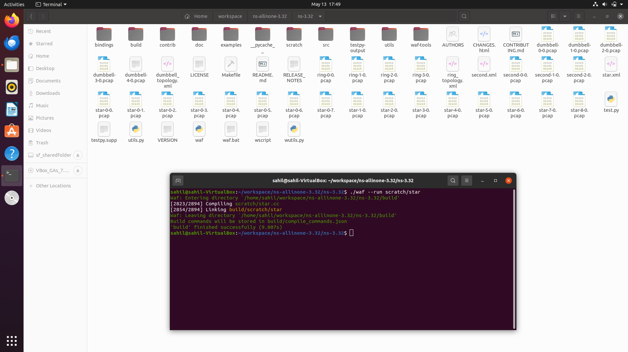

To Visualize type: ./waf –run scratch/star --vis

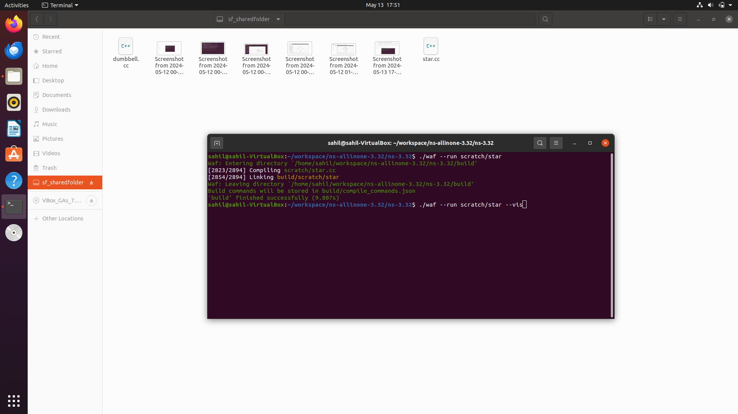

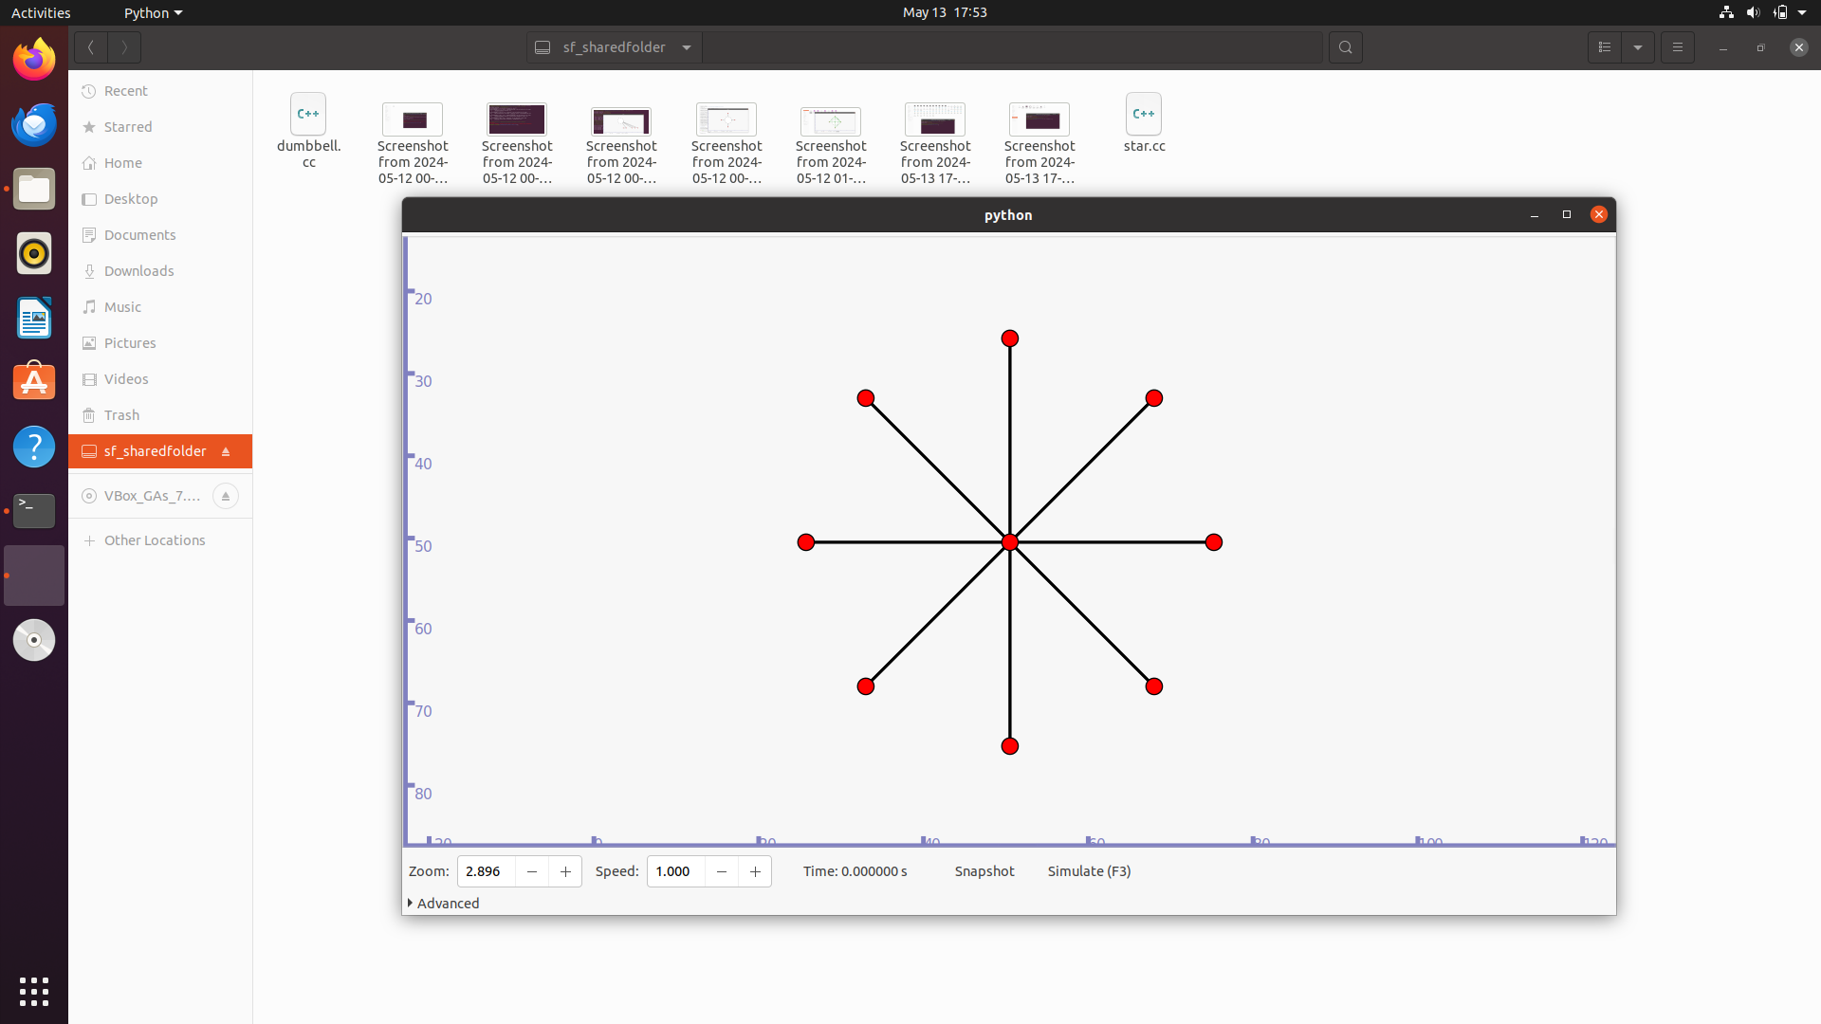

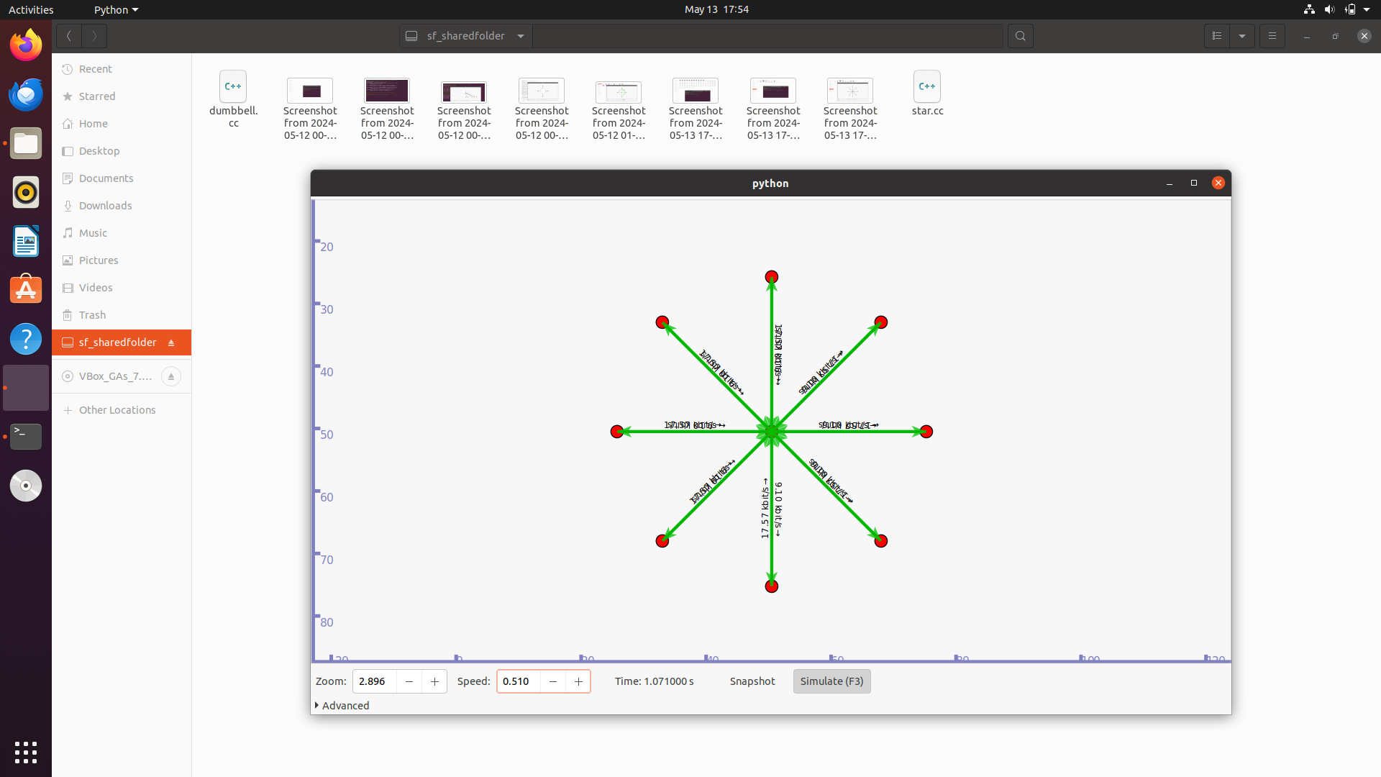

**PRACTICAL NO 9**

**ANIMATE STAR TOPOLOGY IN NETANIM**

**Locate to netanim-3.108 folder type in the terminal -> ./NetAnim**

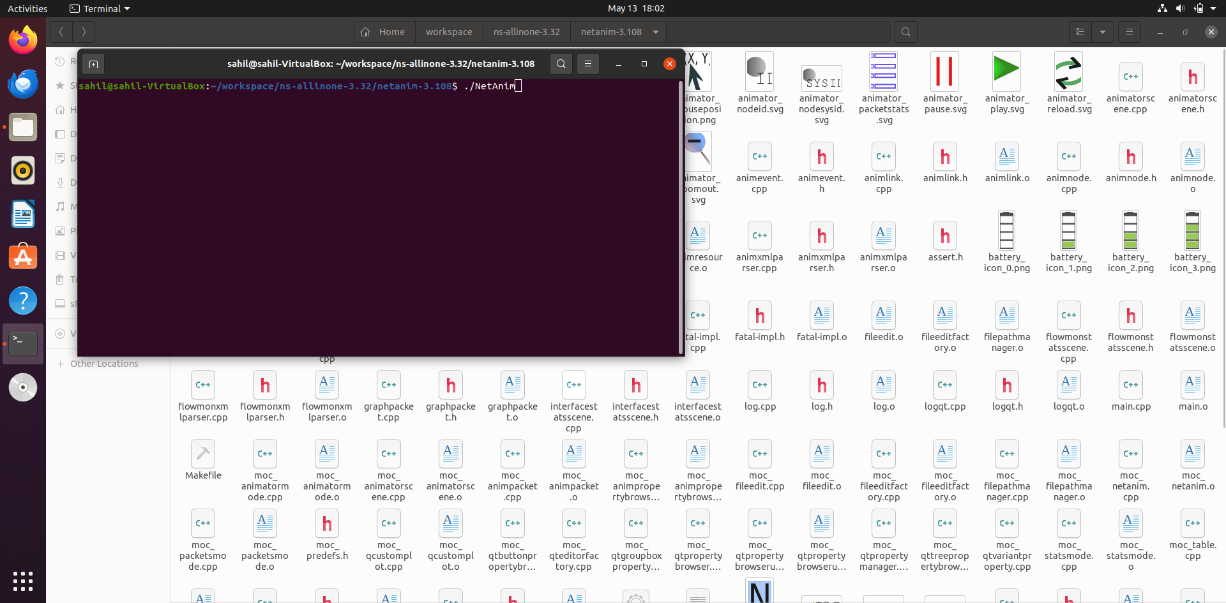

**File -> Locate and Open star.xml File**

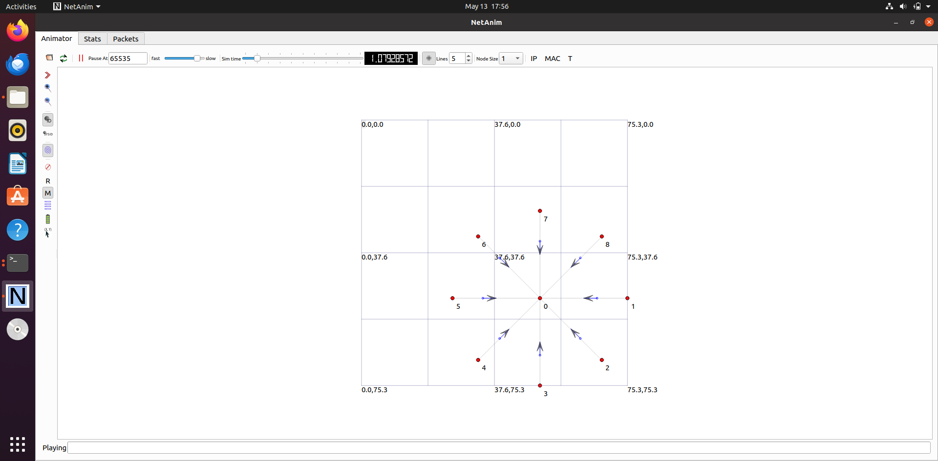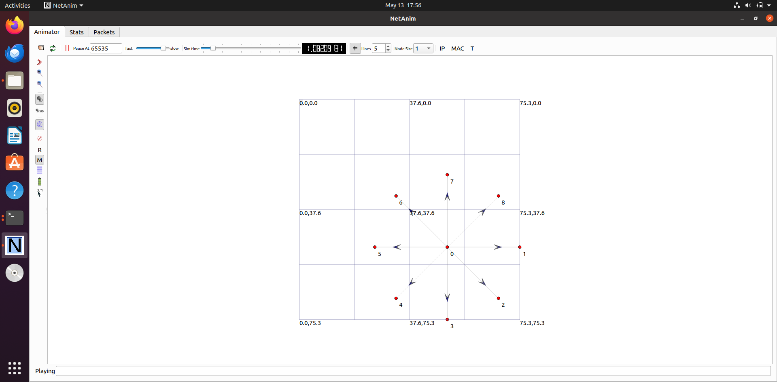

**PRACTICAL NO 10**

**PROGRAM TO SIMULATE MESH TOPOLOGY**

**What is Mesh Topology?**

Mesh topology is a type of network topology where devices are interconnected to multiple other devices, forming a mesh-like structure.

The devices or nodes in this topology connect dynamically, directly, and non-hierarchically to as many other nodes as possible. This generates multiple pathways for data transmission between devices, enhancing fault tolerance and redundancy.

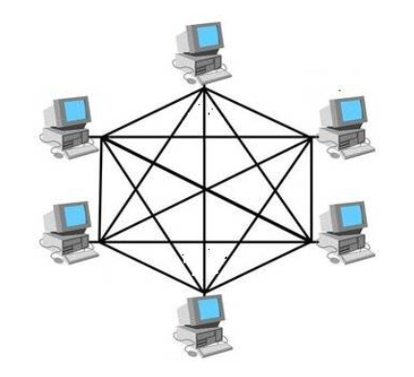

**The disadvantages of Mesh topology:**

* Many wires and complex configurations make setting up and maintaining a mesh network harder.
* Adding devices gets expensive and complicated fast, making large networks challenging.
* Keeping all those devices running uses more power and requires more maintenance, costing you more.
* Fixing problems is trickier because there are many connections to check.
* Setting up a mesh network costs more upfront than other options.

**The advantages of Mesh topology:**

* Even if one connection breaks, the network keeps sending data through other paths.
* The network chooses the fastest and clearest path for your data, making it run smoothly.
* Data travels directly between devices, making it harder for others to see it.
* You can easily add or remove devices without messing up the whole network.

PROGRAM CODE:

#include <iostream>

#include <sstream>

#include <fstream>

#include "ns3/core-module.h"

#include "ns3/internet-module.h"

#include "ns3/network-module.h"

#include "ns3/applications-module.h"

#include "ns3/mesh-module.h"

#include "ns3/mobility-module.h"

#include "ns3/mesh-helper.h"

#include "ns3/yans-wifi-helper.h"

using namespace ns3;

NS_LOG_COMPONENT_DEFINE ("TestMeshScript");

/**

* \ingroup mesh

* \brief MeshTest class

*/

class MeshTest

{

public:

/// Init test

MeshTest ();

/**

* Configure test from command line arguments

*

* \param argc command line argument count

* \param argv command line arguments

*/

void Configure (int argc, char ** argv);

/**

* Run test

* \returns the test status

*/

int Run ();

private:

int m_xSize; ///< X size

int m_ySize; ///< Y size

double m_step; ///< step

double m_randomStart; ///< random start

double m_totalTime; ///< total time

double m_packetInterval; ///< packet interval

uint16_t m_packetSize; ///< packet size

uint32_t m_nIfaces; ///< number interfaces

bool m_chan; ///< channel

bool m_pcap; ///< PCAP

bool m_ascii; ///< ASCII

std::string m_stack; ///< stack

std::string m_root; ///< root

/// List of network nodes

NodeContainer nodes;

/// List of all mesh point devices

NetDeviceContainer meshDevices;

/// Addresses of interfaces:

Ipv4InterfaceContainer interfaces;

/// MeshHelper. Report is not static methods

MeshHelper mesh;

private:

/// Create nodes and setup their mobility

void CreateNodes ();

/// Install internet m_stack on nodes

void InstallInternetStack ();

/// Install applications

void InstallApplication ();

/// Print mesh devices diagnostics

void Report ();

};

MeshTest::MeshTest () :

m_xSize (3),

m_ySize (3),

m_step (100.0),

m_randomStart (0.1),

m_totalTime (100.0),

m_packetInterval (0.1),

m_packetSize (1024),

m_nIfaces (1),

m_chan (true),

m_pcap (false),

m_ascii (false),

m_stack ("ns3::Dot11sStack"),

m_root ("ff:ff:ff:ff:ff:ff")

{

}

void

MeshTest::Configure (int argc, char *argv[])

{

CommandLine cmd (__FILE__);

cmd.AddValue ("x-size", "Number of nodes in a row grid", m_xSize);

cmd.AddValue ("y-size", "Number of rows in a grid", m_ySize);

cmd.AddValue ("step", "Size of edge in our grid (meters)", m_step);

// Avoid starting all mesh nodes at the same time (beacons may collide)

cmd.AddValue ("start", "Maximum random start delay for beacon jitter (sec)", m_randomStart);

cmd.AddValue ("time", "Simulation time (sec)", m_totalTime);

cmd.AddValue ("packet-interval", "Interval between packets in UDP ping (sec)", m_packetInterval);

cmd.AddValue ("packet-size", "Size of packets in UDP ping (bytes)", m_packetSize);

cmd.AddValue ("interfaces", "Number of radio interfaces used by each mesh point", m_nIfaces);

cmd.AddValue ("channels", "Use different frequency channels for different interfaces", m_chan);

cmd.AddValue ("pcap", "Enable PCAP traces on interfaces", m_pcap);

cmd.AddValue ("ascii", "Enable Ascii traces on interfaces", m_ascii);

cmd.AddValue ("stack", "Type of protocol stack. ns3::Dot11sStack by default", m_stack);

cmd.AddValue ("root", "Mac address of root mesh point in HWMP", m_root);

cmd.Parse (argc, argv);

NS_LOG_DEBUG ("Grid:" << m_xSize << "*" << m_ySize);

NS_LOG_DEBUG ("Simulation time: " << m_totalTime << " s");

if (m_ascii)

{

PacketMetadata::Enable ();

}

}

void

MeshTest::CreateNodes ()

{

/*

* Create m_ySize*m_xSize stations to form a grid topology

*/

nodes.Create (m_ySize*m_xSize);

// Configure YansWifiChannel

YansWifiPhyHelper wifiPhy = YansWifiPhyHelper::Default ();

YansWifiChannelHelper wifiChannel = YansWifiChannelHelper::Default ();

wifiPhy.SetChannel (wifiChannel.Create ());

/*

* Create mesh helper and set stack installer to it

* Stack installer creates all needed protocols and install them to

* mesh point device

*/

mesh = MeshHelper::Default ();

if (!Mac48Address (m_root.c_str ()).IsBroadcast ())

{

mesh.SetStackInstaller (m_stack, "Root", Mac48AddressValue (Mac48Address (m_root.c_str ())));

}

else

{

//If root is not set, we do not use "Root" attribute, because it

//is specified only for 11s

mesh.SetStackInstaller (m_stack);

}

if (m_chan)

{

mesh.SetSpreadInterfaceChannels (MeshHelper::SPREAD_CHANNELS);

}

else

{

mesh.SetSpreadInterfaceChannels (MeshHelper::ZERO_CHANNEL);

}

mesh.SetMacType ("RandomStart", TimeValue (Seconds (m_randomStart)));

// Set number of interfaces - default is single-interface mesh point

mesh.SetNumberOfInterfaces (m_nIfaces);

// Install protocols and return container if MeshPointDevices

meshDevices = mesh.Install (wifiPhy, nodes);

// Setup mobility - static grid topology

MobilityHelper mobility;

mobility.SetPositionAllocator ("ns3::GridPositionAllocator",

"MinX", DoubleValue (0.0),

"MinY", DoubleValue (0.0),

"DeltaX", DoubleValue (m_step),

"DeltaY", DoubleValue (m_step),

"GridWidth", UintegerValue (m_xSize),

"LayoutType", StringValue ("RowFirst"));

mobility.SetMobilityModel ("ns3::ConstantPositionMobilityModel");

mobility.Install (nodes);

if (m_pcap)

wifiPhy.EnablePcapAll (std::string ("mp-"));

if (m_ascii)

{

AsciiTraceHelper ascii;

wifiPhy.EnableAsciiAll (ascii.CreateFileStream ("mesh.tr"));

}

}

void

MeshTest::InstallInternetStack ()

{

InternetStackHelper internetStack;

internetStack.Install (nodes);

Ipv4AddressHelper address;

address.SetBase ("10.1.1.0", "255.255.255.0");

interfaces = address.Assign (meshDevices);

}

void

MeshTest::InstallApplication ()

{

UdpEchoServerHelper echoServer (9);

ApplicationContainer serverApps = echoServer.Install (nodes.Get (0));

serverApps.Start (Seconds (0.0));

serverApps.Stop (Seconds (m_totalTime));

UdpEchoClientHelper echoClient (interfaces.GetAddress (0), 9);

echoClient.SetAttribute ("MaxPackets", UintegerValue ((uint32_t)(m_totalTime*(1/m_packetInterval))));

echoClient.SetAttribute ("Interval", TimeValue (Seconds (m_packetInterval)));

echoClient.SetAttribute ("PacketSize", UintegerValue (m_packetSize));

ApplicationContainer clientApps = echoClient.Install (nodes.Get (m_xSize*m_ySize-1));

clientApps.Start (Seconds (0.0));

clientApps.Stop (Seconds (m_totalTime));

}

int

MeshTest::Run ()

{

CreateNodes ();

InstallInternetStack ();

InstallApplication ();

Simulator::Schedule (Seconds (m_totalTime), &MeshTest::Report, this);

Simulator::Stop (Seconds (m_totalTime));

/*//Netanim code

std::string animFile = "star.xml";

// Set the bounding box for animation

star.BoundingBox (1, 1, 100, 100);

// Create the animation object and configure for specified output

AnimationInterface anim (animFile);*/

Simulator::Run ();

Simulator::Destroy ();

return 0;

}

void

MeshTest::Report ()

{

unsigned n (0);

for (NetDeviceContainer::Iterator i = meshDevices.Begin (); i != meshDevices.End (); ++i, ++n)

{

std::ostringstream os;

os << "mp-report-" << n << ".xml";

std::cerr << "Printing mesh point device #" << n << " diagnostics to " << os.str () << "\n";

std::ofstream of;

of.open (os.str ().c_str ());

if (!of.is_open ())

{

std::cerr << "Error: Can't open file " << os.str () << "\n";

return;

}

mesh.Report (*i, of);

of.close ();

}

}

int

main (int argc, char *argv[])

{

MeshTest t;

t.Configure (argc, argv);

return t.Run ();

}

OUTPUT:

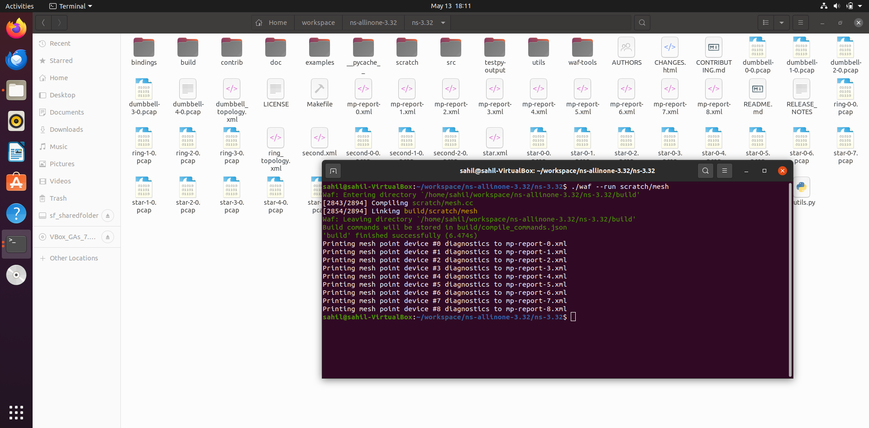

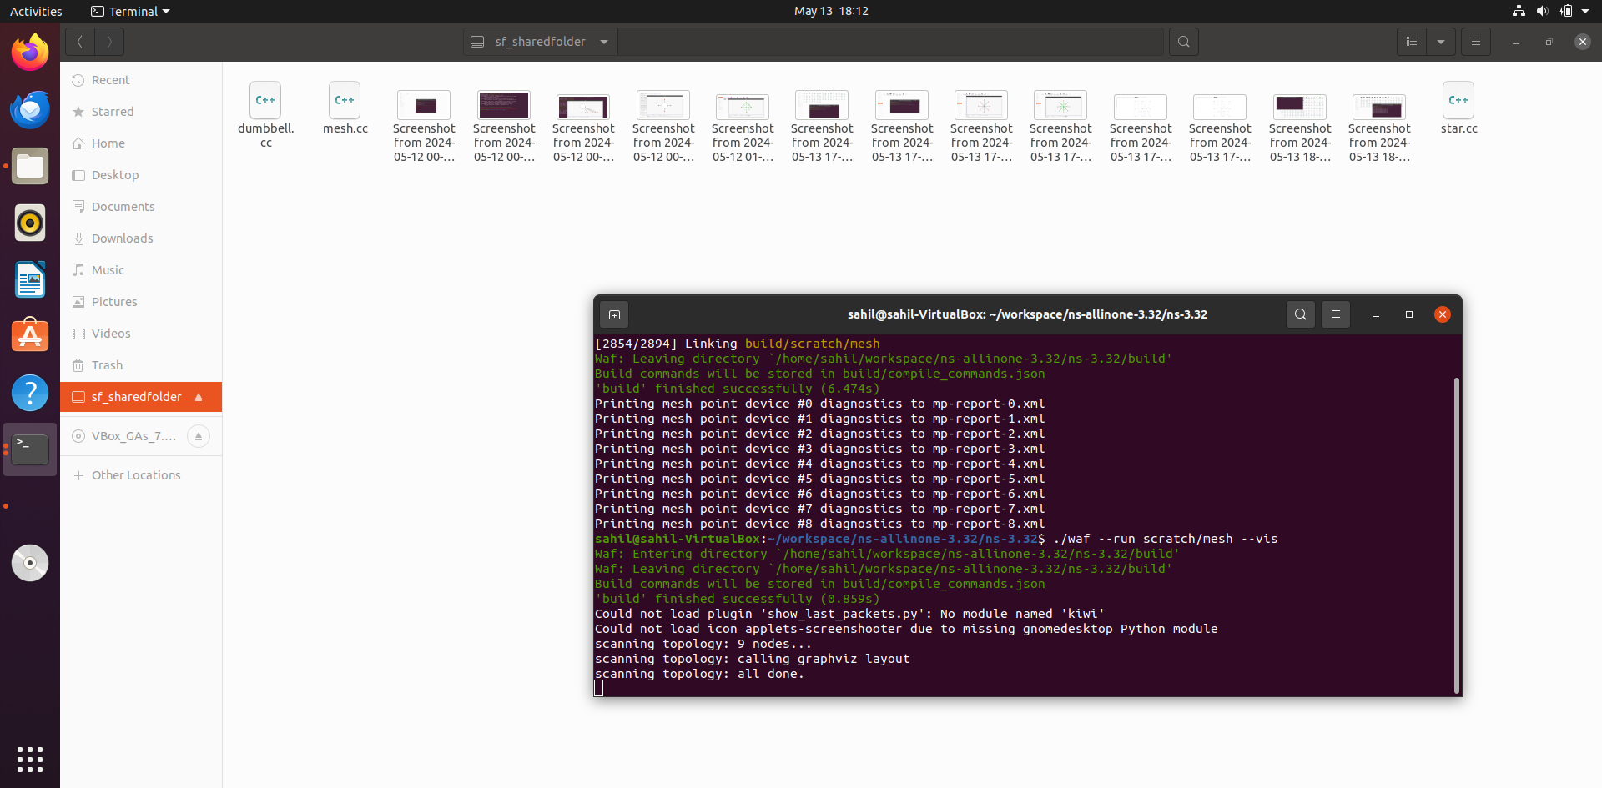

**PRACTICAL NO 11**

**PROGRAM TO SIMULATE HYBRID TOPOLOGY (PROGRAM TO CONNECT WIFI, POINT TO POINT AND CSMA NODES)**

**What is Hybrid Topology?**

A hybrid topology is a kind of network topology that is a combination of two or more network topologies, such as mesh topology, bus topology, and ring topology. Its usage and choice are dependent on its deployments and requirements like the performance of the desired network, and the number of computers, their location. The below figure is describing the structure of hybrid topology that contains more than one topology.

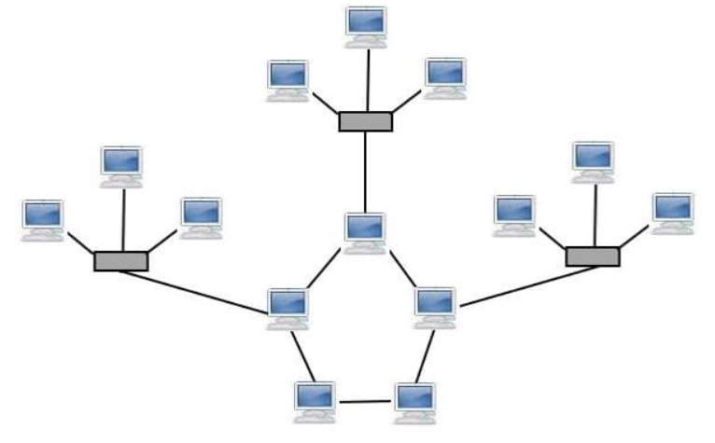

**Advantages of Hybrid topology**

* **Reliable:** It is more reliable as it has better fault tolerance. If a node gets damaged between the network, it is possible in this network to singled out the damaged node from rest of the network. Also, in this case, without impacting the processing of the network, the needed steps can be taken.
* **Effective:** This is the biggest advantage of hybrid topology. The weakness of the several topologies connected in this topology is ignored. And, there is a consideration only about the strengths of these different topologies. For case, the high tolerance capability is offered by star topology, and good data reliability is provided by ring topology. Therefore, in hybrid star-ring topology, these two-function work quite well.

**Disadvantages of Hybrid topology**

* **Complexity:** To manage the topology become challenging, as the different topologies are linked in the hybrid topology. It is a difficult job for designers and not easy to create this type of architecture. There is a need to be very efficient for the installation and configuration process.
* **Expensive:** Purchasing and maintaining the hybrid topology is much expensive while comparing with other topologies. The hubs are also required in this network topology that are used to connect two different networks, and they are also expensive. Furthermore, the hybrid topology may need advanced network devices, a lot of cables, and more as its architectures are usually larger in scale.

**PROGRAM CODE:**

#include "ns3/core-module.h"

#include "ns3/point-to-point-module.h"

#include "ns3/network-module.h"

#include "ns3/applications-module.h"

#include "ns3/mobility-module.h"

#include "ns3/csma-module.h"

#include "ns3/internet-module.h"

#include "ns3/yans-wifi-helper.h"

#include "ns3/ssid.h"

using namespace ns3;

NS_LOG_COMPONENT_DEFINE ("ThirdScriptExample");

int

main (int argc, char *argv[])

{

bool verbose = true;

uint32_t nCsma = 3;

uint32_t nWifi = 3;

bool tracing = false;

CommandLine cmd (__FILE__);

cmd.AddValue ("nCsma", "Number of \"extra\" CSMA nodes/devices", nCsma);

cmd.AddValue ("nWifi", "Number of wifi STA devices", nWifi);

cmd.AddValue ("verbose", "Tell echo applications to log if true", verbose);

cmd.AddValue ("tracing", "Enable pcap tracing", tracing);

cmd.Parse (argc,argv);

// The underlying restriction of 18 is due to the grid position

// allocator's configuration; the grid layout will exceed the

// bounding box if more than 18 nodes are provided.

if (nWifi > 18)

{

std::cout << "nWifi should be 18 or less; otherwise grid layout exceeds the bounding box" << std::endl;

return 1;

}

if (verbose)

{

LogComponentEnable ("UdpEchoClientApplication", LOG_LEVEL_INFO);

LogComponentEnable ("UdpEchoServerApplication", LOG_LEVEL_INFO);

}

NodeContainer p2pNodes;

p2pNodes.Create (2);

PointToPointHelper pointToPoint;

pointToPoint.SetDeviceAttribute ("DataRate", StringValue ("5Mbps"));

pointToPoint.SetChannelAttribute ("Delay", StringValue ("2ms"));

NetDeviceContainer p2pDevices;

p2pDevices = pointToPoint.Install (p2pNodes);

NodeContainer csmaNodes;

csmaNodes.Add (p2pNodes.Get (1));

csmaNodes.Create (nCsma);

CsmaHelper csma;

csma.SetChannelAttribute ("DataRate", StringValue ("100Mbps"));

csma.SetChannelAttribute ("Delay", TimeValue (NanoSeconds (6560)));

NetDeviceContainer csmaDevices;

csmaDevices = csma.Install (csmaNodes);

NodeContainer wifiStaNodes;

wifiStaNodes.Create (nWifi);

NodeContainer wifiApNode = p2pNodes.Get (0);

YansWifiChannelHelper channel = YansWifiChannelHelper::Default ();

YansWifiPhyHelper phy = YansWifiPhyHelper::Default ();

phy.SetChannel (channel.Create ());

WifiHelper wifi;

wifi.SetRemoteStationManager ("ns3::AarfWifiManager");

WifiMacHelper mac;

Ssid ssid = Ssid ("ns-3-ssid");

mac.SetType ("ns3::StaWifiMac",

"Ssid", SsidValue (ssid),

"ActiveProbing", BooleanValue (false));

NetDeviceContainer staDevices;

staDevices = wifi.Install (phy, mac, wifiStaNodes);

mac.SetType ("ns3::ApWifiMac",

"Ssid", SsidValue (ssid));

NetDeviceContainer apDevices;

apDevices = wifi.Install (phy, mac, wifiApNode);

MobilityHelper mobility;

mobility.SetPositionAllocator ("ns3::GridPositionAllocator",

"MinX", DoubleValue (0.0),

"MinY", DoubleValue (0.0),

"DeltaX", DoubleValue (5.0),

"DeltaY", DoubleValue (10.0),

"GridWidth", UintegerValue (3),

"LayoutType", StringValue ("RowFirst"));

mobility.SetMobilityModel ("ns3::RandomWalk2dMobilityModel",

"Bounds", RectangleValue (Rectangle (-50, 50, -50, 50)));

mobility.Install (wifiStaNodes);

mobility.SetMobilityModel ("ns3::ConstantPositionMobilityModel");

mobility.Install (wifiApNode);

InternetStackHelper stack;

stack.Install (csmaNodes);

stack.Install (wifiApNode);

stack.Install (wifiStaNodes);

Ipv4AddressHelper address;

address.SetBase ("10.1.1.0", "255.255.255.0");

Ipv4InterfaceContainer p2pInterfaces;

p2pInterfaces = address.Assign (p2pDevices);

address.SetBase ("10.1.2.0", "255.255.255.0");

Ipv4InterfaceContainer csmaInterfaces;

csmaInterfaces = address.Assign (csmaDevices);

address.SetBase ("10.1.3.0", "255.255.255.0");

address.Assign (staDevices);

address.Assign (apDevices);

UdpEchoServerHelper echoServer (9);

ApplicationContainer serverApps = echoServer.Install (csmaNodes.Get (nCsma));

serverApps.Start (Seconds (1.0));

serverApps.Stop (Seconds (10.0));

UdpEchoClientHelper echoClient (csmaInterfaces.GetAddress (nCsma), 9);

echoClient.SetAttribute ("MaxPackets", UintegerValue (1));

echoClient.SetAttribute ("Interval", TimeValue (Seconds (1.0)));

echoClient.SetAttribute ("PacketSize", UintegerValue (1024));

ApplicationContainer clientApps =

echoClient.Install (wifiStaNodes.Get (nWifi - 1));

clientApps.Start (Seconds (2.0));

clientApps.Stop (Seconds (10.0));

Ipv4GlobalRoutingHelper::PopulateRoutingTables ();

Simulator::Stop (Seconds (10.0));

if (tracing == true)

{

pointToPoint.EnablePcapAll ("third");

phy.EnablePcap ("third", apDevices.Get (0));

csma.EnablePcap ("third", csmaDevices.Get (0), true);

}

Simulator::Run ();

Simulator::Destroy ();

return 0;

}

**OUTPUT:**

**Open Terminal Locate ns-3 folder and type the following command:**

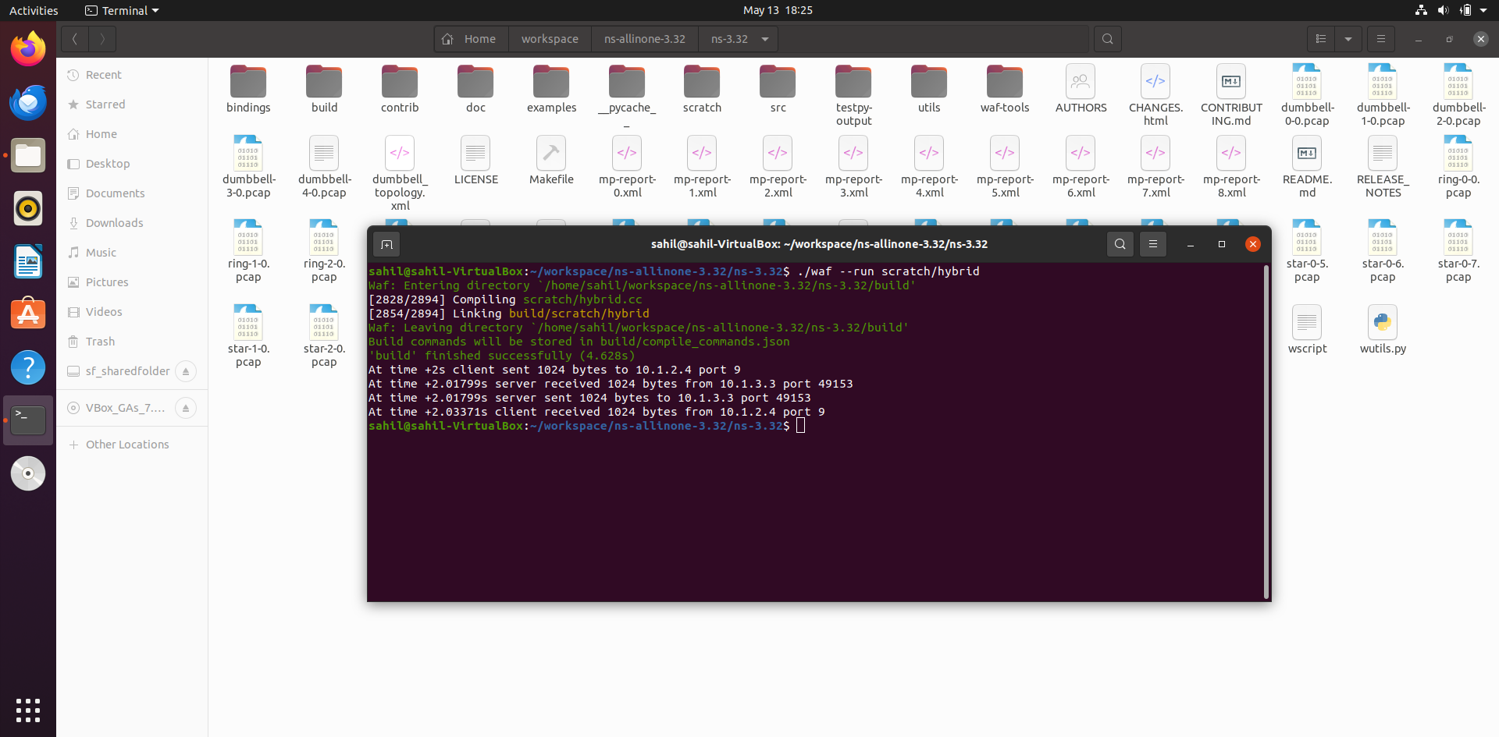

**For visualization type the following command:**

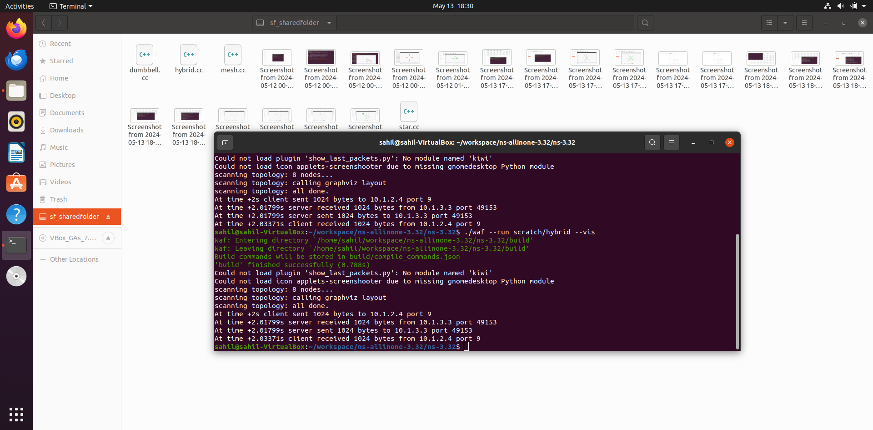

**Visualizing Hybrid Topology:**

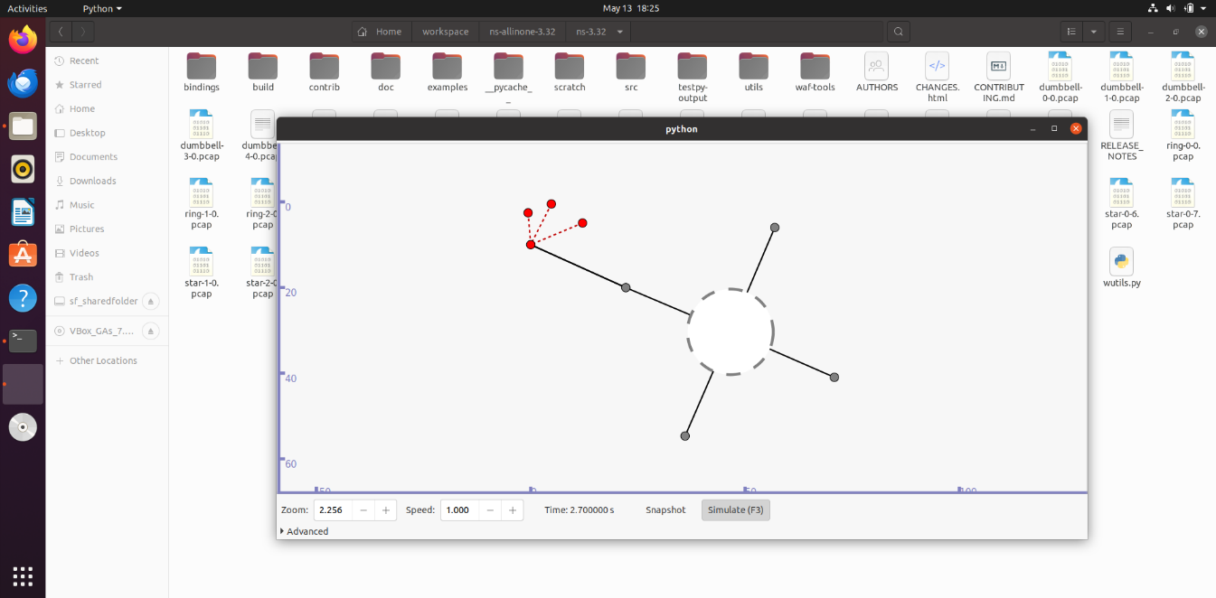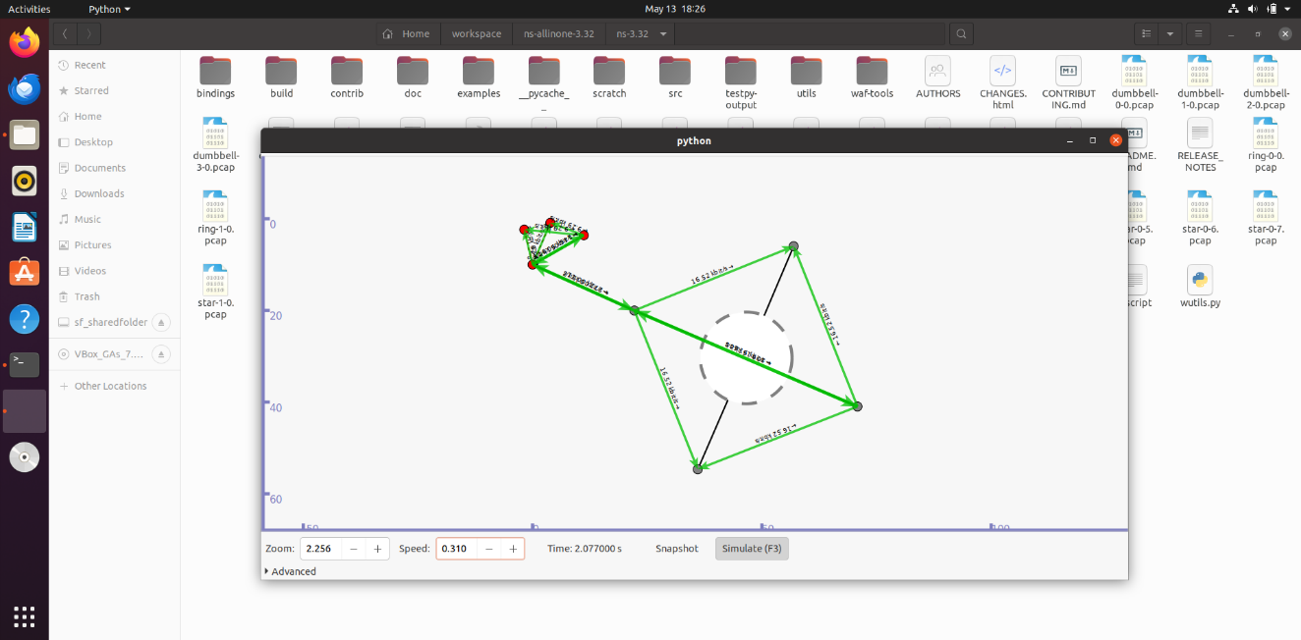

**PRACTICAL NO 12**

**PROGRAM TO SIMULATE UDP CLIENT-SERVER**

**UDP Client-Server Implementation**

There are two primary transport layer protocols to communicate between hosts: TCP and UDP.

Theory: In UDP, the client does not form a connection with the server like in TCP and instead sends a datagram. Similarly, the server need not accept a connection and just waits for datagrams to arrive. Datagrams upon arrival contain the address of the sender which the server uses to send data to the correct client.

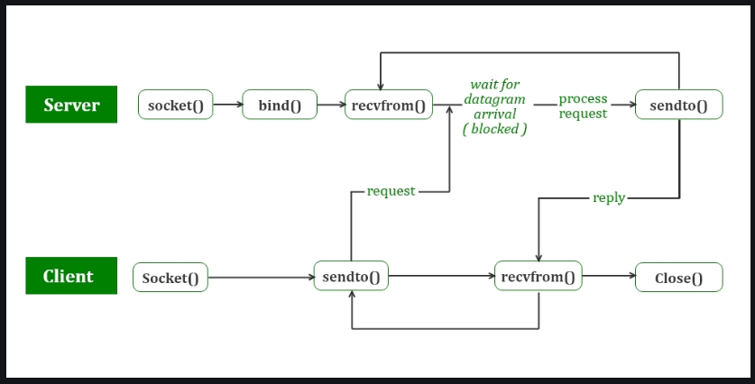

The entire process can be broken down into the following steps :

**UDP Server :**

Create a UDP socket.

Bind the socket to the server address.

Wait until the datagram packet arrives from the client.

Process the datagram packet and send a reply to the client.

Go back to Step 3.

**UDP Client :**

Create a UDP socket.

Send a message to the server.

Wait until a response from the server is received.

Process the reply and go back to step 2, if necessary.

Close socket descriptor and exit.

**PROGRAM:**

#include <fstream>

#include <ns3/core-module.h>

#include <ns3/csma-module.h>

#include <ns3/applications-module.h>

#include <ns3/internet-module.h>

using namespace ns3;

NS_LOG_COMPONENT_DEFINE ("UdpClientServerExample");

int

main (int argc, char *argv[])

{

LogComponentEnable ("UdpClient", LOG_LEVEL_INFO);

LogComponentEnable ("UdpServer", LOG_LEVEL_INFO);

bool useV6 = false;

Address serverAddress;

CommandLine cmd (__FILE__);

cmd.AddValue ("useV6", "use Ipv6", useV6);

cmd.Parse (argc, argv);

NS_LOG_INFO ("Create Nodes.");

NodeContainer n;

n.Create (2);

InternetStackHelper internet;

internet.Install (n);

NS_LOG_INFO ("Create Channels.");

CsmaHelper csma;

csma.SetChannelAttribute ("DataRate", DataRateValue (DataRate (5000000)));

csma.SetChannelAttribute ("Delay", TimeValue (MilliSeconds (2)));

csma.SetDeviceAttribute ("Mtu", UintegerValue (1400));

NetDeviceContainer d = csma.Install (n);

NS_LOG_INFO ("Assign IP Addresses");

if (useV6 == false)

{

Ipv4AddressHelper ipv4;

ipv4.SetBase ("10.1.1.0", "255.255.255.0");

Ipv4InterfaceContainer i = ipv4.Assign (d);

serverAddress = Address (i.GetAddress (1));

}

else

{

Ipv6AddressHelper ipv6;

ipv6.SetBase ("2001:0000:f00d:cafe::", Ipv6Prefix (64));

Ipv6InterfaceContainer i6 = ipv6.Assign (d);

serverAddress = Address(i6.GetAddress (1,1));

}

NS_LOG_INFO ("Create Applications.");

uint16_t port = 4000;

UdpServerHelper server (port);

ApplicationContainer apps = server.Install (n.Get (1));

apps.Start (Seconds (1.0));

apps.Stop (Seconds (10.0));

uint32_t MaxPacketSize = 1024;

Time interPacketInterval = Seconds (0.05);

uint32_t maxPacketCount = 320;

UdpClientHelper client (serverAddress, port);

client.SetAttribute ("MaxPackets", UintegerValue (maxPacketCount));

client.SetAttribute ("Interval", TimeValue (interPacketInterval));

client.SetAttribute ("PacketSize", UintegerValue (MaxPacketSize));

apps = client.Install (n.Get (0));

apps.Start (Seconds (2.0));

apps.Stop (Seconds (10.0));

NS_LOG_INFO ("Run Simulation.");

Simulator::Run ();

Simulator::Destroy();

NS_LOG_INFO ("Done.");

}

OUTPUT:

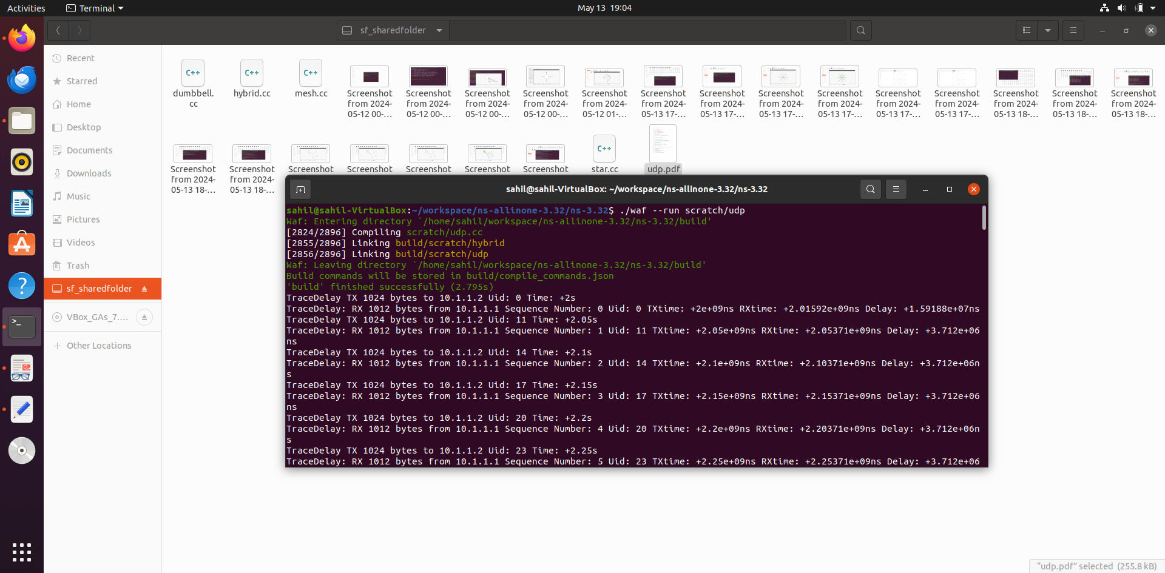

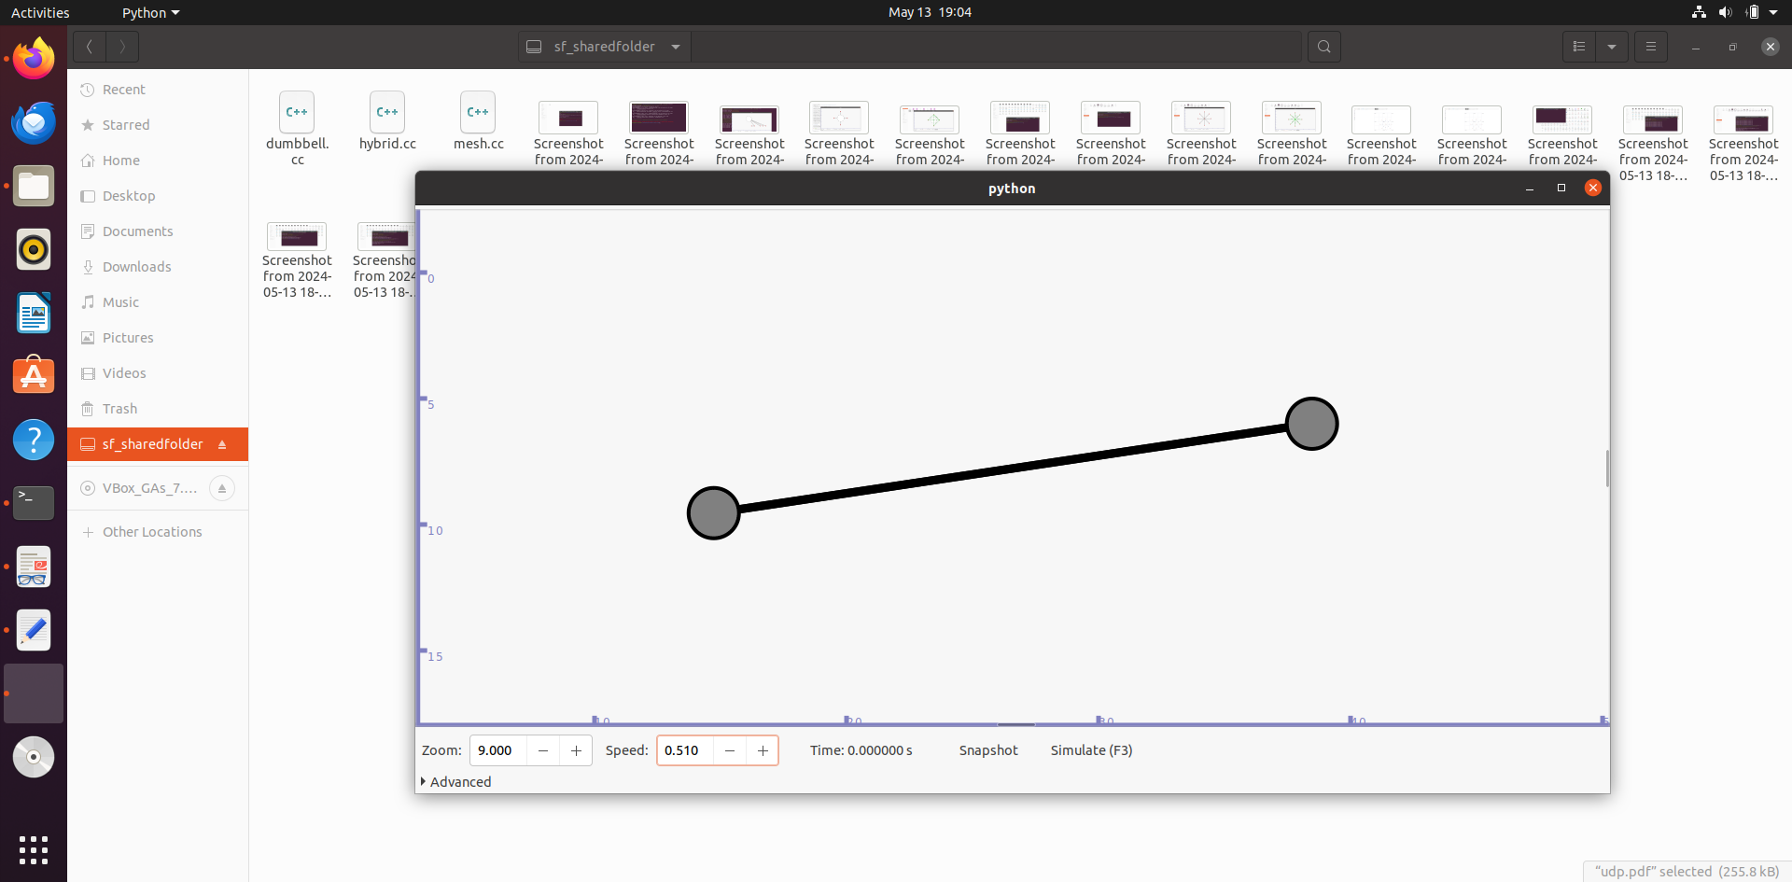

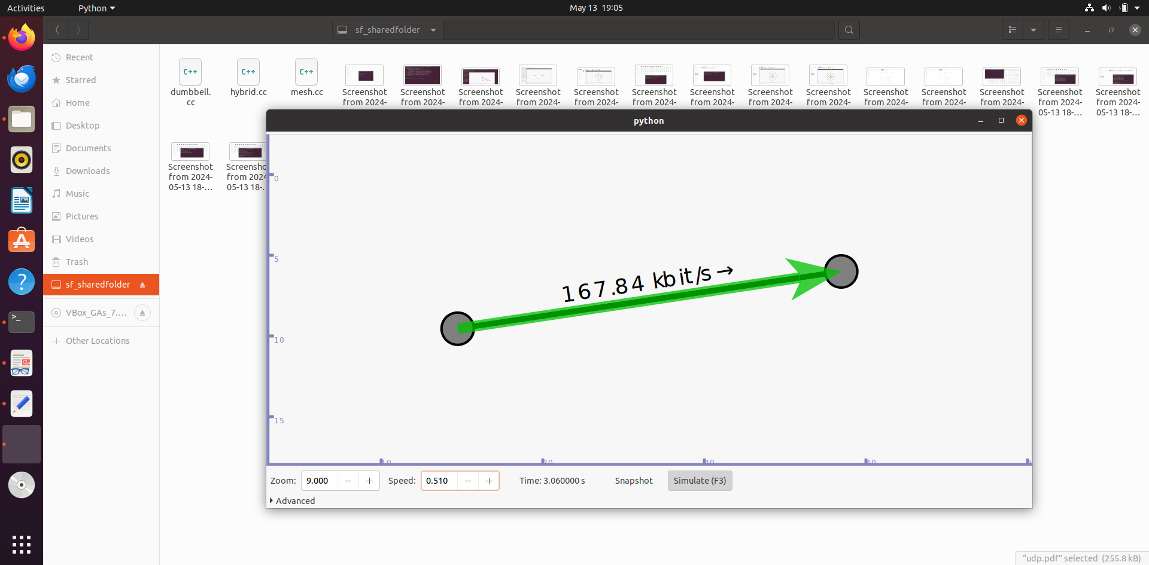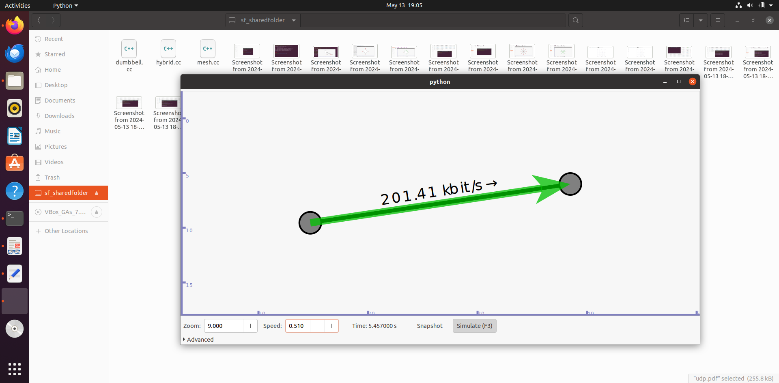

**PRACTICAL NO 13**

**PROGRAM TO SIMULATE DHCP SERVER AND N CLIENTS**

**What is DHCP (Dynamic Host Configuration Protocol)?**

DHCP (Dynamic Host Configuration Protocol) is a network management protocol used to dynamically assign an IP address to any device, or node, on a network so it can communicate using IP. DHCP automates and centrally manages these configurations rather than requiring network administrators to manually assign IP addresses to all network devices. DHCP can be implemented on small local networks, as well as large enterprise networks.

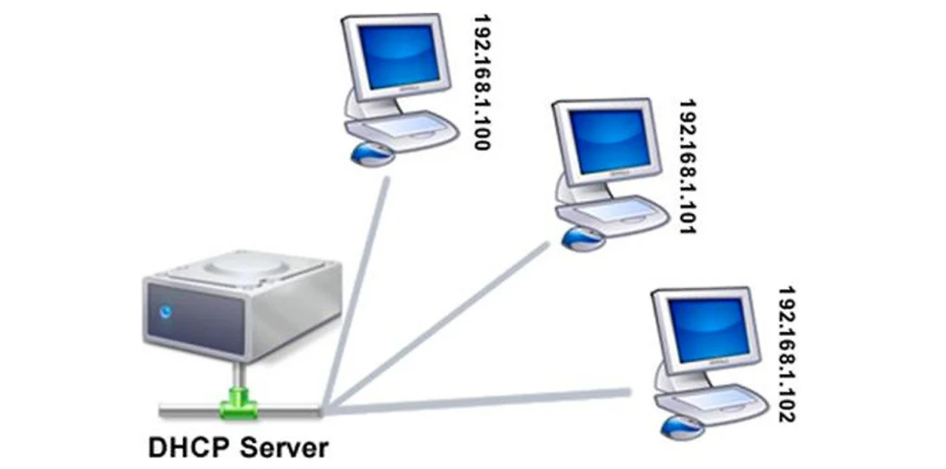

DHCP assigns new IP addresses in each location when devices are moved from place to place, which means network administrators do not have to manually configure each device with a valid IP address or reconfigure the device with a new IP address if it moves to a new location on the network.

**Pros and cons of DHCP**

DHCP makes it easier for network administrators to add or move devices within a network, whether it be a LAN or WAN. But DHCP is not inherently secure, and if malicious actors access the DHCP server, they can wreak havoc. Also, if the DHCP server does not have a backup and the server fails, so do the devices served by it.

**PROGRAM:**

#include "ns3/core-module.h"

#include "ns3/internet-apps-module.h"

#include "ns3/csma-module.h"

#include "ns3/internet-module.h"

#include "ns3/point-to-point-module.h"

#include "ns3/applications-module.h"

using namespace ns3;

NS_LOG_COMPONENT_DEFINE ("DhcpExample");

int

main (int argc, char *argv[])

{

CommandLine cmd (__FILE__);

bool verbose = true;

bool tracing = true;

cmd.AddValue ("verbose", "turn on the logs", verbose);

cmd.AddValue ("tracing", "turn on the tracing", tracing);

cmd.Parse (argc, argv);

// GlobalValue::Bind ("ChecksumEnabled", BooleanValue (true));

if (verbose)

{

LogComponentEnable ("DhcpServer", LOG_LEVEL_ALL);

LogComponentEnable ("DhcpClient", LOG_LEVEL_ALL);

LogComponentEnable ("UdpEchoServerApplication", LOG_LEVEL_INFO);

LogComponentEnable ("UdpEchoClientApplication", LOG_LEVEL_INFO);

}

Time stopTime = Seconds (20);

NS_LOG_INFO ("Create nodes.");

NodeContainer nodes;

NodeContainer router;

nodes.Create (3);

router.Create (2);

NodeContainer net (nodes, router);

NS_LOG_INFO ("Create channels.");

CsmaHelper csma;

csma.SetChannelAttribute ("DataRate", StringValue ("5Mbps"));

csma.SetChannelAttribute ("Delay", StringValue ("2ms"));

csma.SetDeviceAttribute ("Mtu", UintegerValue (1500));

NetDeviceContainer devNet = csma.Install (net);

NodeContainer p2pNodes;

p2pNodes.Add (net.Get (4)); //R1 router. Adding R1 to point to point network

p2pNodes.Create (1); // Creating node A

PointToPointHelper pointToPoint;

pointToPoint.SetDeviceAttribute ("DataRate", StringValue ("5Mbps"));

pointToPoint.SetChannelAttribute ("Delay", StringValue ("2ms"));

//netdevice for Point to point

NetDeviceContainer p2pDevices;

p2pDevices = pointToPoint.Install (p2pNodes);

InternetStackHelper tcpip;

tcpip.Install (nodes);

tcpip.Install (router);

tcpip.Install (p2pNodes.Get (1)); //A

Ipv4AddressHelper address;

address.SetBase ("172.30.1.0", "255.255.255.0");

Ipv4InterfaceContainer p2pInterfaces;

p2pInterfaces = address.Assign (p2pDevices);

// manually add a routing entry because we don't want to add a dynamic routing

Ipv4StaticRoutingHelper ipv4RoutingHelper;

Ptr<Ipv4> ipv4Ptr = p2pNodes.Get (1)->GetObject<Ipv4> (); //A

Ptr<Ipv4StaticRouting> staticRoutingA = ipv4RoutingHelper.GetStaticRouting (ipv4Ptr);

staticRoutingA->AddNetworkRouteTo (Ipv4Address ("172.30.0.0"), Ipv4Mask ("/24"),

Ipv4Address ("172.30.1.1"), 1);

NS_LOG_INFO ("Setup the IP addresses and create DHCP applications.");

DhcpHelper dhcpHelper;

// The router must have a fixed IP.

/*InstallFixedAddress ( Ptr< NetDevice > netDevice,

Ipv4Address addr,

Ipv4Mask mask

) */

//Assign IP address of R1

Ipv4InterfaceContainer fixedNodes = dhcpHelper.InstallFixedAddress (devNet.Get (4), Ipv4Address ("172.30.0.17"), Ipv4Mask ("/24"));

// Not really necessary, IP forwarding is enabled by default in IPv4.

fixedNodes.Get (0).first->SetAttribute ("IpForward", BooleanValue (true));

// Configuring DHCP server R0

/*DhcpHelper::InstallDhcpServer ( Ptr< NetDevice > netDevice,

Ipv4Address serverAddr, //IP address of R0

Ipv4Address poolAddr,

Ipv4Mask poolMask,

Ipv4Address minAddr,

Ipv4Address maxAddr,

Ipv4Address gateway = Ipv4Address ()// R1

) */

ApplicationContainer dhcpServerApp = dhcpHelper.InstallDhcpServer (devNet.Get (3), Ipv4Address ("172.30.0.12"),

Ipv4Address ("172.30.0.0"), Ipv4Mask ("/24"),

Ipv4Address ("172.30.0.10"), Ipv4Address ("172.30.0.15"),

Ipv4Address ("172.30.0.17"));

// This is just to show how it can be done.

//DHCP static IP for N2

DynamicCast<DhcpServer> (dhcpServerApp.Get (0))->AddStaticDhcpEntry (devNet.Get (2)->GetAddress (), Ipv4Address ("172.30.0.14"));

dhcpServerApp.Start (Seconds (0.0));

dhcpServerApp.Stop (stopTime);

// Configuring DHCP clients

// Netdevice for DHCP clients

NetDeviceContainer dhcpClientNetDevs;

dhcpClientNetDevs.Add (devNet.Get (0)); // N0

dhcpClientNetDevs.Add (devNet.Get (1)); // N2

dhcpClientNetDevs.Add (devNet.Get (2)); //N3

// installing DHCP client Application on N0, N1 and N2

ApplicationContainer dhcpClients = dhcpHelper.InstallDhcpClient (dhcpClientNetDevs);

dhcpClients.Start (Seconds (1.0));

dhcpClients.Stop (stopTime);

UdpEchoServerHelper echoServer (9);

ApplicationContainer serverApps = echoServer.Install (p2pNodes.Get (1));

serverApps.Start (Seconds (0.0));

serverApps.Stop (stopTime);

UdpEchoClientHelper echoClient (p2pInterfaces.GetAddress (1), 9);

echoClient.SetAttribute ("MaxPackets", UintegerValue (100));

echoClient.SetAttribute ("Interval", TimeValue (Seconds (1.0)));

echoClient.SetAttribute ("PacketSize", UintegerValue (1024));

ApplicationContainer clientApps = echoClient.Install (nodes.Get (1));

clientApps.Start (Seconds (10.0));

clientApps.Stop (stopTime);

Simulator::Stop (stopTime + Seconds (10.0));

if (tracing)

{

csma.EnablePcapAll ("dhcp-csma");

pointToPoint.EnablePcapAll ("dhcp-p2p");

}

NS_LOG_INFO ("Run Simulation.");

Simulator::Run ();

Simulator::Destroy ();

NS_LOG_INFO ("Done.");

}  
  
**OUTPUT:**

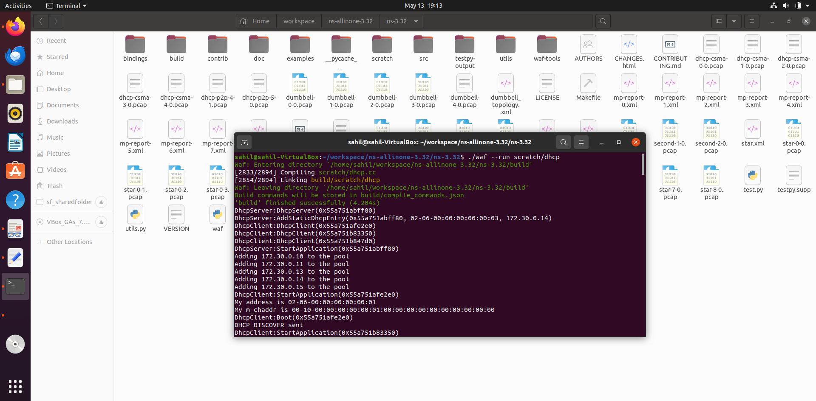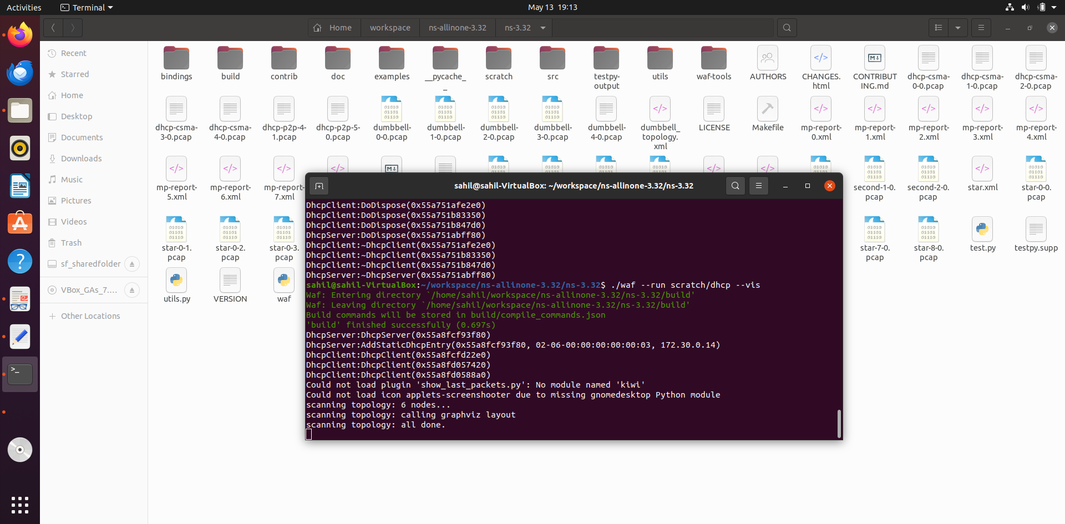

VISUALIZING DHCP

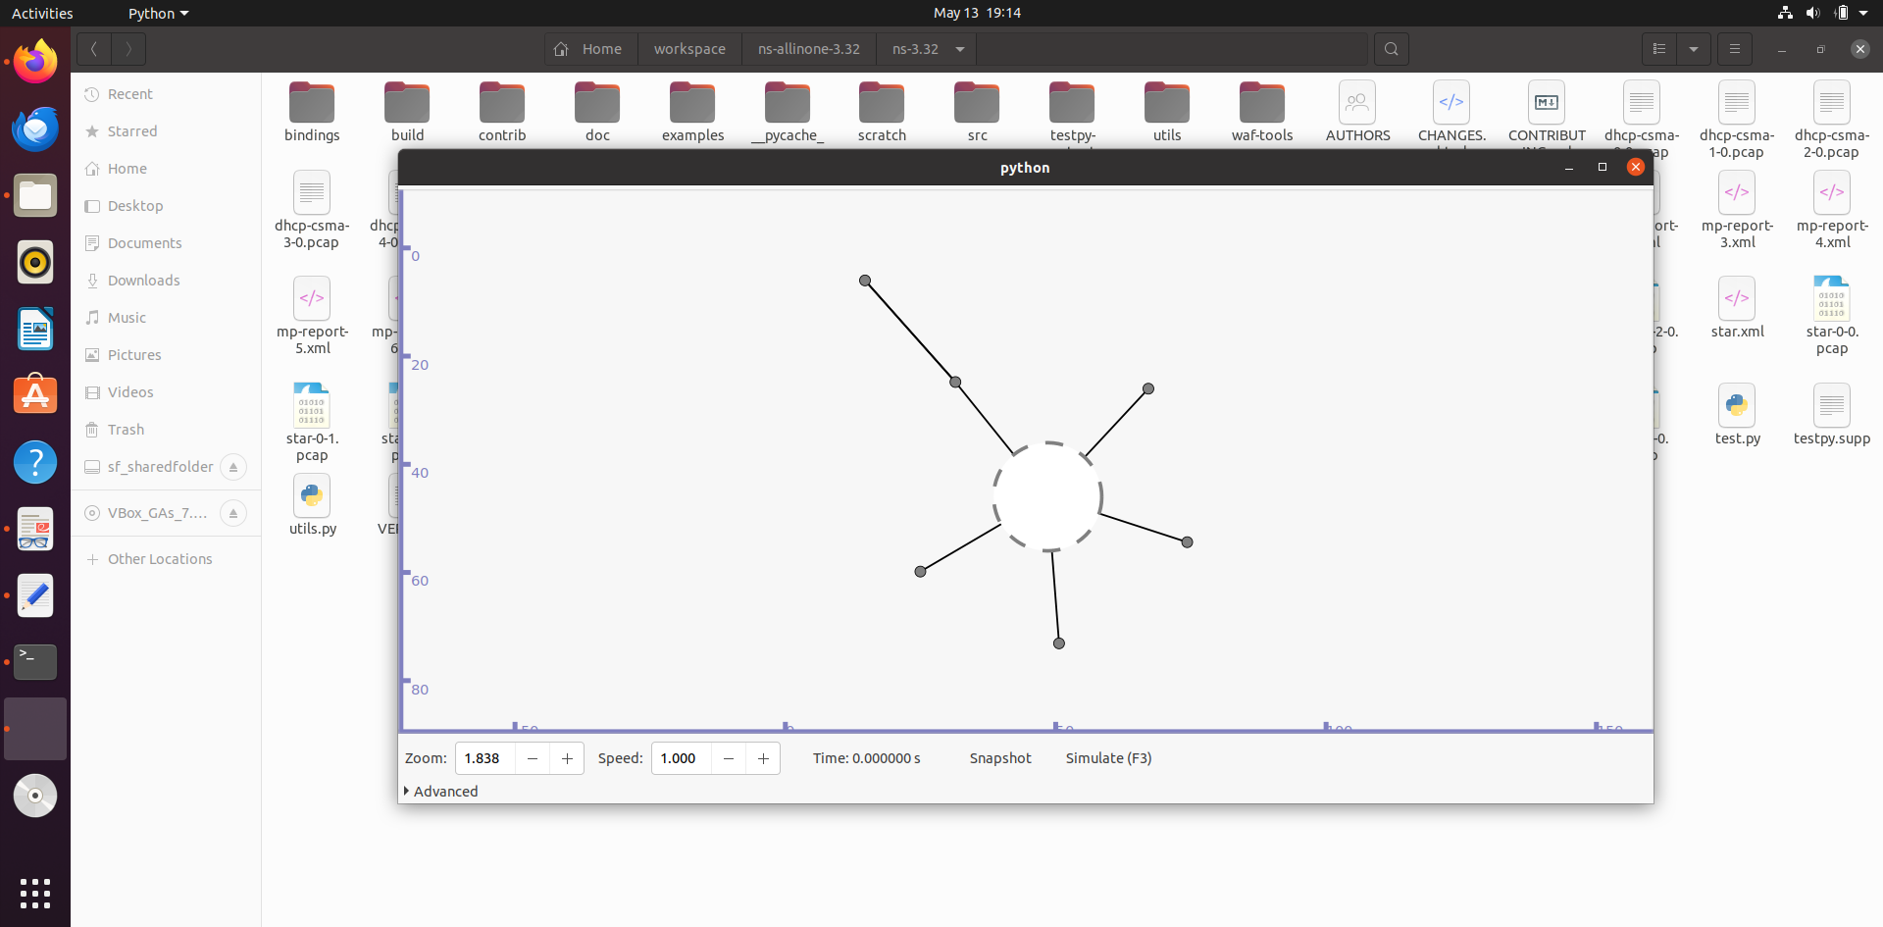

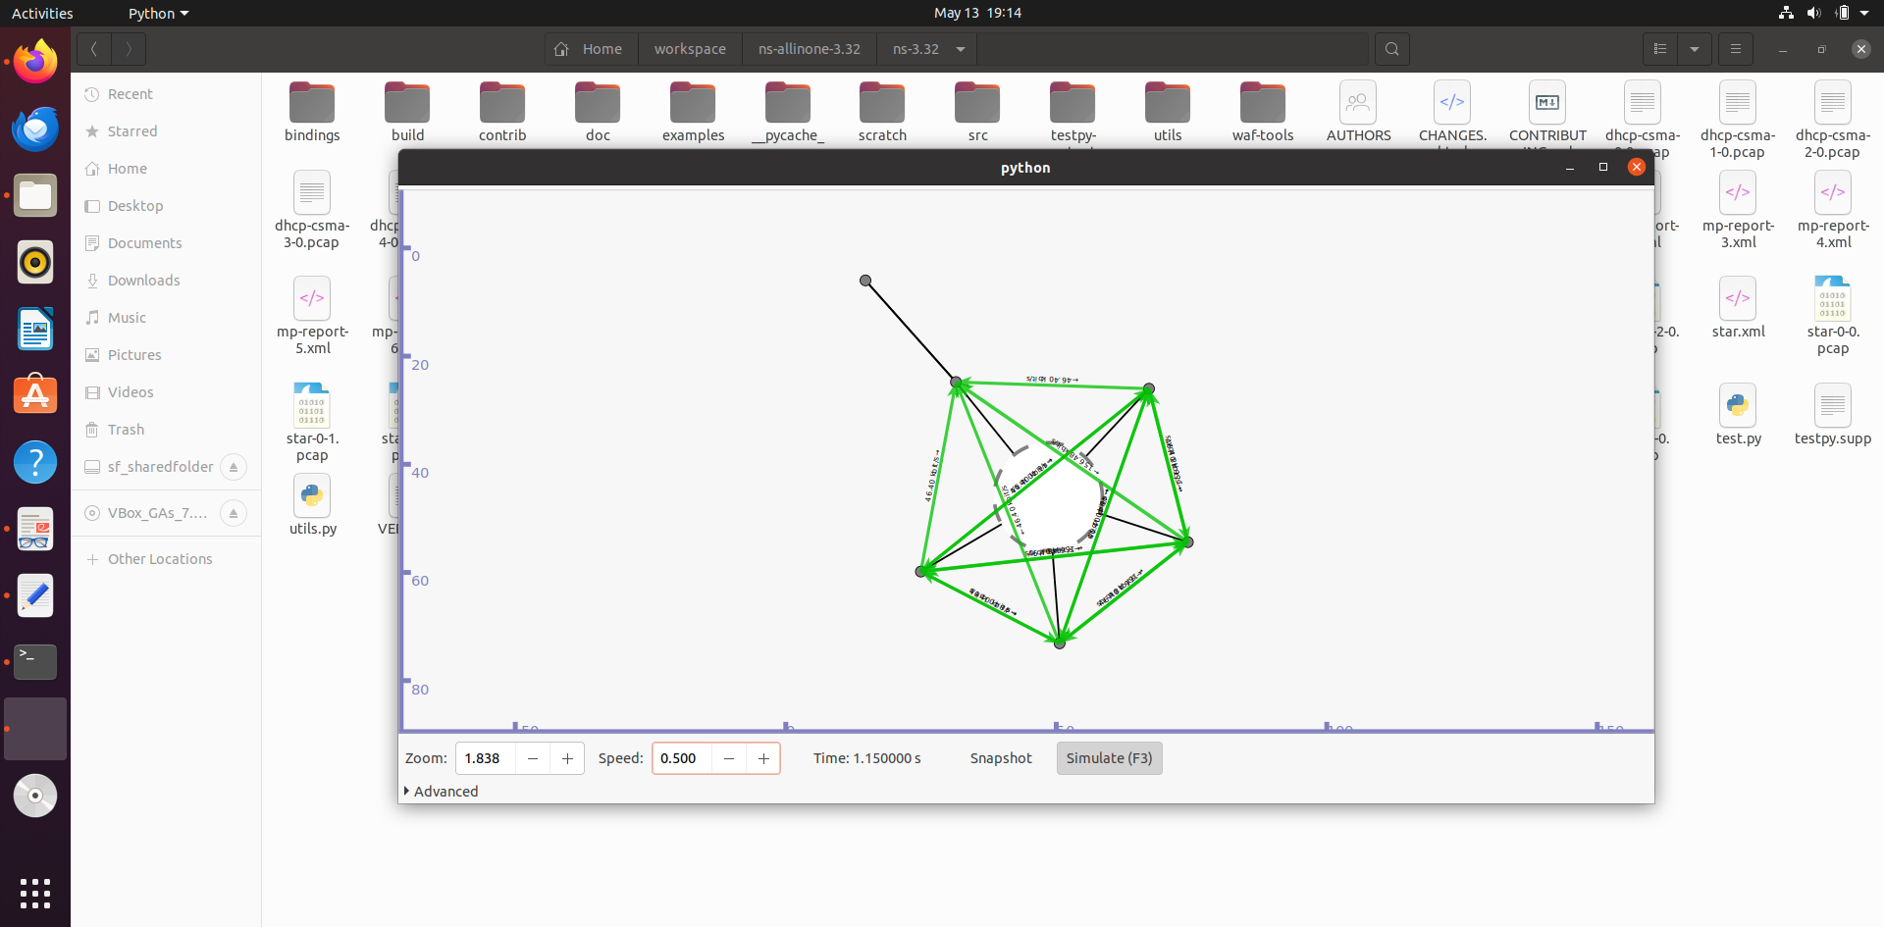

**PRACTICAL NO 14**

**PROGRAM TO SIMULATE FTP USING TCP PROTOCOL**

**FTP (File Transfer Protocol): Defined and Explained**

FTP (File Transfer Protocol) is a standard network protocol used for the transfer of files from one host to another over a TCP-based network, such as the Internet.

FTP works by opening two connections that link the computers trying to communicate with each other. One connection is designated for the commands and replies that get sent between the two clients, and the other channel handles the transfer of data.

**What is FTP useful for?**

One of the main reasons why modern businesses and individuals need FTP is its ability to perform large file size transfers. When sending a relatively small file, like a Word document, most methods will do, but with FTP, you can send hundreds of gigabytes at once and still get a smooth transmission.

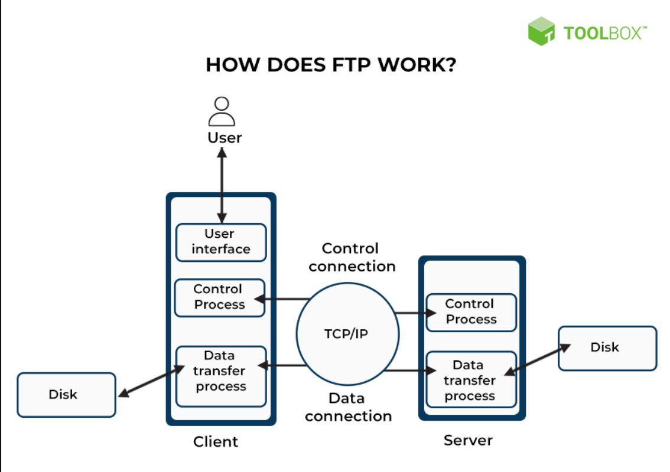

**Advantages of FTP**

* File sharing also comes in the category of advantages of FTP in this between two machines files can be shared on the network.
* Speed is one of the main benefits of FTP.

**Disadvantages of FTP**

* File size limit is the drawback of FTP only 2 GB size files can be transferred.
* More then one receivers are not supported by FTP.
* FTP does not encrypt the data this is one of the biggest drawbacks of FTP.
* FTP is unsecured we use login IDs and passwords making it secure but they can be attacked by hackers.

**PROGRAM:**

#include "ns3/core-module.h"

#include "ns3/network-module.h"

#include "ns3/internet-module.h"

#include "ns3/point-to-point-module.h"

#include "ns3/applications-module.h"

#include "ns3/csma-module.h"

#include "ns3/ipv4-global-routing-helper.h"

using namespace ns3;

NS_LOG_COMPONENT_DEFINE ("FTP_Simulation");

int main(int argc, char *argv[])

{

Time::SetResolution (Time::NS);

LogComponentEnable ("OnOffApplication", LOG_LEVEL_INFO);

LogComponentEnable ("OnOffApplication", LOG_LEVEL_INFO);

NodeContainer csmaNodes;

csmaNodes.Create(2);

// using csma helper to configure attributes

// and creating connectivity between two nodes

CsmaHelper csma;

// set channel attributes for device

csma.SetChannelAttribute ("DataRate",StringValue("1Mbps"));

csma.SetChannelAttribute ("Delay",StringValue("20ms"));

// installing nodes to create, configure, install devices of required type

NetDeviceContainer csmaDevices;

csmaDevices = csma.Install(csmaNodes);

// installing protocol stack in nodes; once executed will install TCP,UDP, IP etc. on each node of the nodeContainer

InternetStackHelper stack;

stack.Install(csmaNodes);

// assigning IP address to the devices, setting base address here

Ipv4AddressHelper address;

address.SetBase ("10.10.10.0","255.255.255.0");

Ipv4InterfaceContainer csmaInterfaces =address.Assign(csmaDevices);

// assigning ip address to the devices, since devices contain nodes, while ip stack is created within a node

// unint32_t port_num=21; // port number for Rx

Address RxAddress(InetSocketAddress (csmaInterfaces.GetAddress(1), 21)); //Rx obtaining a IPv4 address, and the port number to listen

PacketSinkHelper sinkHelper ("ns3::TcpSocketFactory", RxAddress); // PacketSinkHelper is a class reference for creating socket references and passing address at which Rx is instantiated

ApplicationContainer sinkApp = sinkHelper.Install (csmaNodes.Get(1)); // ApplicationContainer, installs application on the node, in our case it is packet sink helper ; node here is the server node

sinkApp.Start (Seconds (1.0));

sinkApp.Stop (Seconds (10.0));

//creating a TCP transmitter

// set up address and port number to send TCP traffic to the server

Address TxAddress(InetSocketAddress(csmaInterfaces.GetAddress(1),21));

OnOffHelper clientHelper ("ns3::TcpSocketFactory", TxAddress);

// setting up attributes for onoff application helper

clientHelper.SetAttribute("DataRate",StringValue("1Mbps"));

clientHelper.SetAttribute("PacketSize",UintegerValue(1280));

ApplicationContainer Tx = clientHelper.Install (csmaNodes.Get (0));

Tx.Start (Seconds (1.0));

Tx.Stop (Seconds (10.0));

csma.EnablePcap("ftpeg",csmaDevices.Get(1),true);

AsciiTraceHelper ascii;

csma.EnableAsciiAll(ascii.CreateFileStream ("ftp_trace.tr"));

NS_LOG_INFO ("Run Simulation.");

Simulator::Run ();

NS_LOG_INFO ("Done");

return(0);

}

**OUTPUT:**

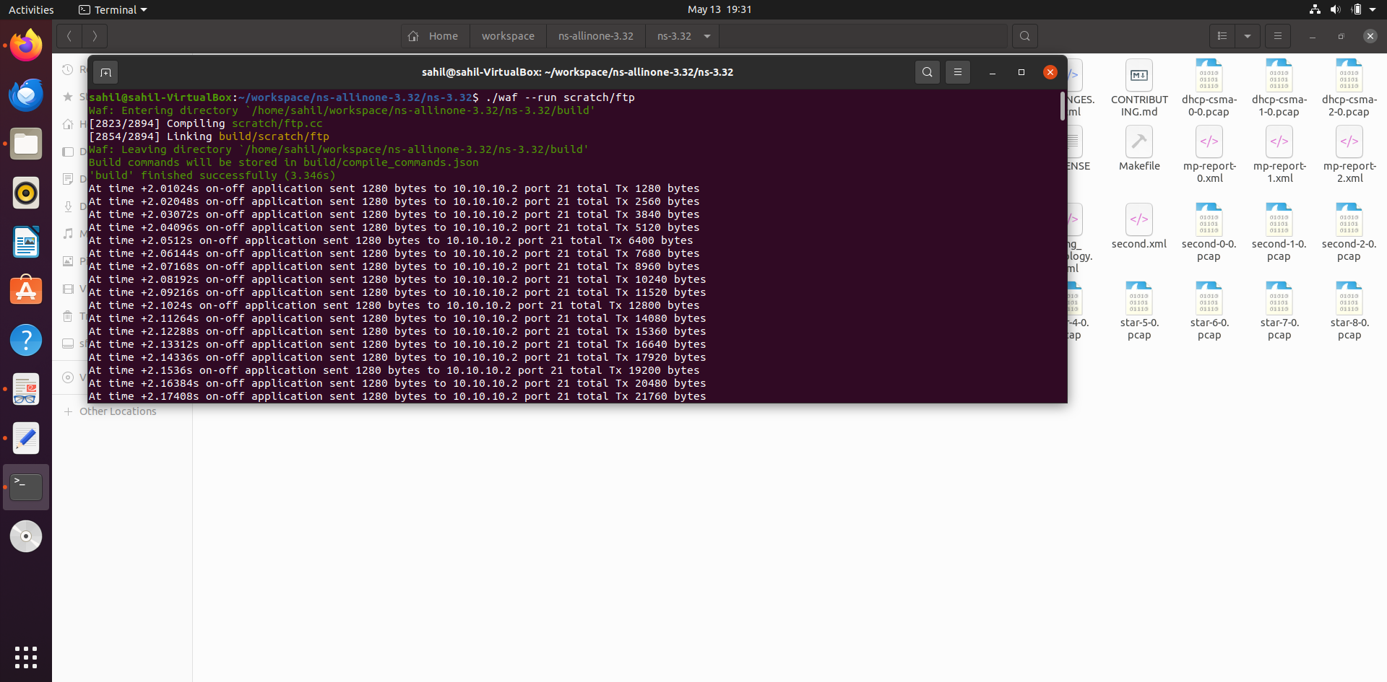

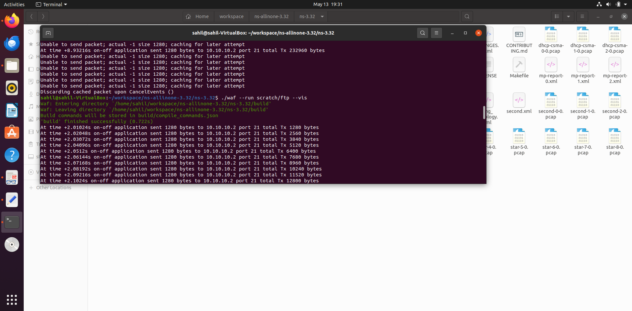

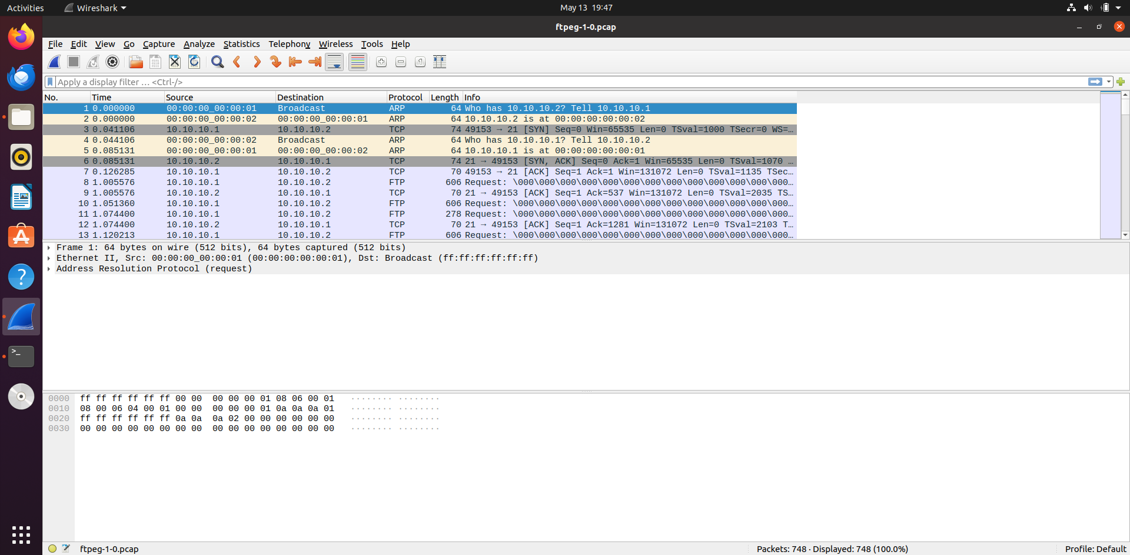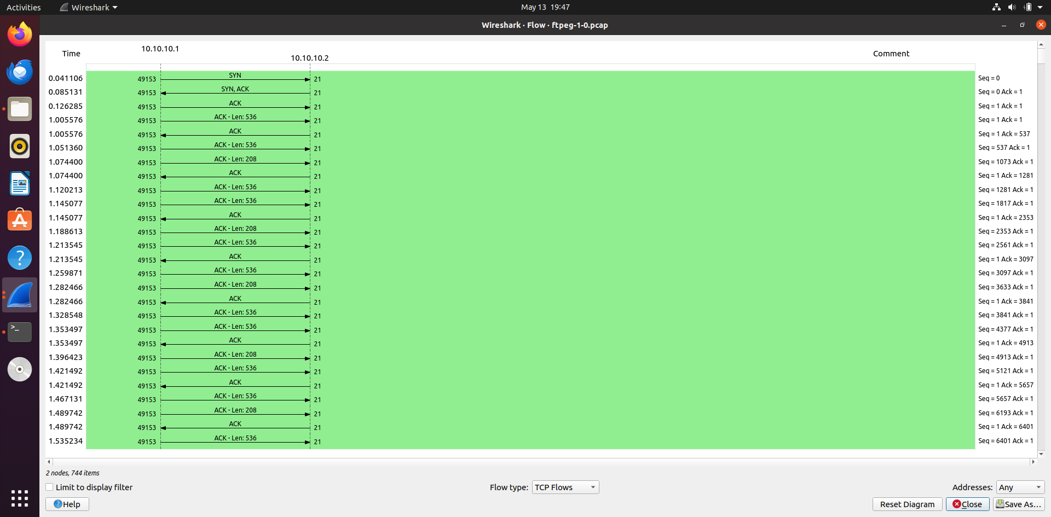

**PRACTICAL NO 15**

**PROGRAM TO SIMULATE THREE WAY HANDSHAKE FOR TCP CONNECTION**

**Three Way Handshake for TCP Connection**

This could also be seen as a way of how TCP connection is established. Before getting into the details, let us look at some basics. TCP stands for Transmission Control Protocol which indicates that it does something to control the transmission of the data in a reliable way.

The process of communication between devices over the internet happens according to the current TCP/IP suite model(stripped out version of OSI reference model). The Application layer is a top pile of a stack of TCP/IP models from where network referenced applications like web browsers on the client-side establish a connection with the server. From the application layer, the information is transferred to the transport layer where our topic comes into the picture. The two important protocols of this layer are – TCP, UDP(User Datagram Protocol) out of which TCP is prevalent(since it provides reliability for the connection established). However, you can find an application of UDP in querying the DNS server to get the binary equivalent of the Domain Name used for the website.

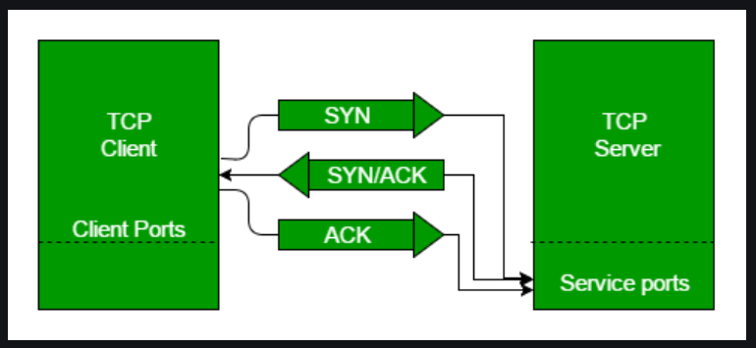

* **Step 1 (SYN):** In the first step, the client wants to establish a connection with a server, so it sends a segment with SYN(Synchronize Sequence Number) which informs the server that the client is likely to start communication and with what sequence number it starts segments with.
* **Step 2 (SYN + ACK):** Server responds to the client request with SYN-ACK signal bits set. Acknowledgement(ACK) signifies the response of the segment it received and SYN signifies with what sequence number it is likely to start the segments with.
* **Step 3 (ACK):** In the final part client acknowledges the response of the server and they both establish a reliable connection with which they will start the actual data transfer.

**PRACTICAL NO 16**

**ANALYZE THE ABOVE TOPOLOGY NETWORK TRAFFIC USING WIRESHARK.**

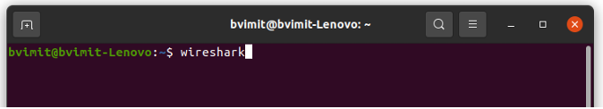

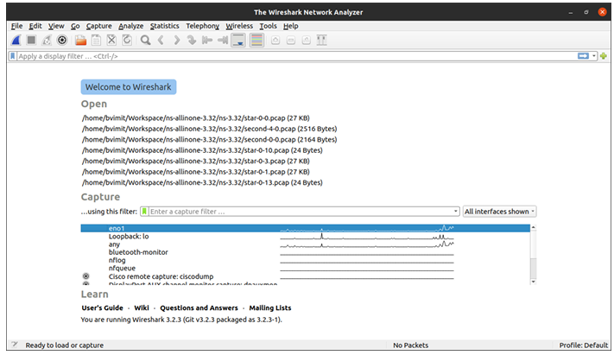





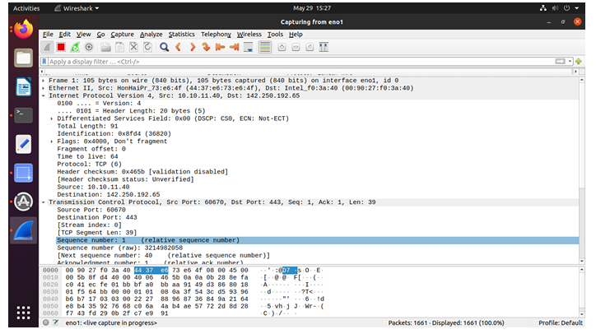

**TOPIC: DUMBBELL TOPOLOGY**

**Theory:**

The term "dumbbell topology" typically refers to a specific network topology configuration incomputer networks. In this configuration, a central node is connected to two other nodes, creatinga shape that resembles a dumbbell. Each of the two outer nodes can also be connected to othernodes, forming a larger network. The dumbbell topology is often used in network design toprovide redundancy and fault tolerance. By having two paths from any node to the central node,if one path fails, the network can still function using the alternate path. This redundancy helpsensure high availability and reliability of the network.

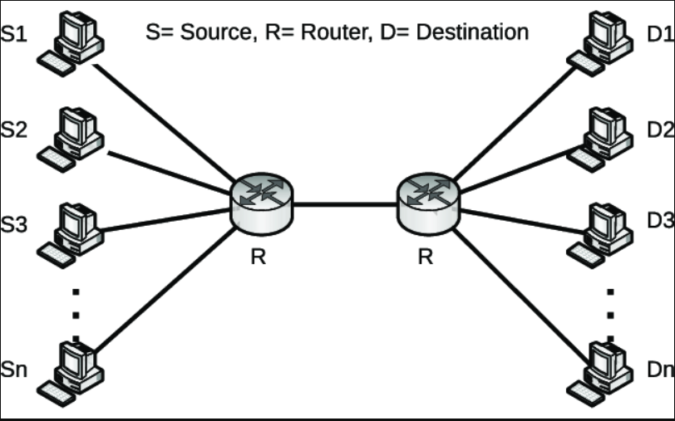

**Advantages of Dumbbell Topology:**

* **Fault Tolerance:** Dumbbell topology provides redundancy. If one ring fails, data can still flow through the other ring, ensuring network reliability.
* **Scalability:** It's relatively easy to expand a dumbbell network by adding more peripheral nodes or even additional rings.

**Disadvantages of Dumbbell Topology:**

* **Complexity:** Dumbbell networks can be more complex to design, implement, and manage compared to simpler topologies like star or ring networks.
* **Cost:** Implementing redundancy and maintaining multiple rings can increase the cost of the network infrastructure.

PROGRAM:

#include <iostream>

#include "ns3/core-module.h"

#include "ns3/network-module.h"

#include "ns3/internet-module.h"

#include "ns3/point-to-point-module.h"

#include "ns3/netanim-module.h"

#include "ns3/applications-module.h"

#include "ns3/point-to-point-layout-module.h"

using namespace ns3;

int main (int argc, char *argv[])

{

Config::SetDefault ("ns3::OnOffApplication::PacketSize", UintegerValue(512));

Config::SetDefault ("ns3::OnOffApplication::DataRate", StringValue ("500kb/s"));

uint32_t nLeftLeaf = 5;

uint32_t nRightLeaf = 5;

uint32_t nLeaf = 0; // If non-zero, number of both left and right

std::string animFile = "dumbbell-animation.xml"; // Name of file for animation output

CommandLine cmd;

cmd.AddValue ("nLeftLeaf", "Number of left side leaf nodes", nLeftLeaf);

cmd.AddValue ("nRightLeaf","Number of right side leaf nodes", nRightLeaf);

cmd.AddValue ("nLeaf", "Number of left and right side leaf nodes", nLeaf);

cmd.AddValue ("animFile", "File Name for Animation Output", animFile);

cmd.Parse (argc,argv);

if (nLeaf > 0)

{

nLeftLeaf = nLeaf;

nRightLeaf = nLeaf;

}

// Create the point-to-point link helpers

PointToPointHelper pointToPointRouter;

pointToPointRouter.SetDeviceAttribute("DataRate", StringValue("10Mbps"));

pointToPointRouter.SetChannelAttribute("Delay", StringValue("1ms"));

PointToPointHelper pointToPointLeaf;

pointToPointLeaf.SetDeviceAttribute("DataRate", StringValue("10Mbps"));

pointToPointLeaf.SetChannelAttribute("Delay", StringValue("1ms"));

PointToPointDumbbellHelper d(nLeftLeaf, pointToPointLeaf,

nRightLeaf, pointToPointLeaf,

pointToPointRouter);

// Install Stack

InternetStackHelper stack;

d.InstallStack (stack);

// Assign IP Addresses

d.AssignIpv4Addresses(Ipv4AddressHelper("10.1.1.0", "255.255.255.0"),

Ipv4AddressHelper("10.2.1.0", "255.255.255.0"),

Ipv4AddressHelper("10.3.1.0", "255.255.255.0"));

// Install on/off app on all right side nodes

OnOffHelper clientHelper("ns3::UdpSocketFactory", Address());

clientHelper.SetAttribute("OnTime", StringValue("ns3::UniformRandomVariable"));

clientHelper.SetAttribute("OffTime", StringValue("ns3::UniformRandomVariable"));

ApplicationContainer clientApps;

for (uint32_t i = 0; i < d.RightCount (); ++i)

{

AddressValue remoteAddress(InetSocketAddress(d.GetLeftIpv4Address(i), 1000));

clientHelper.SetAttribute("Remote", remoteAddress);

clientApps.Add(clientHelper.Install(d.GetRight(i)));

}

clientApps.Start(Seconds(0.0));

clientApps.Stop(Seconds(10.0));

// Set the bounding box for animation

d.BoundingBox(1, 1, 100, 100);

// Create the animation object and configure for specified output

AnimationInterface anim(animFile);

// Set up the actual simulation

Ipv4GlobalRoutingHelper::PopulateRoutingTables();

Simulator::Run();

std::cout << "Animation Trace file created:" << animFile << std::endl;

Simulator::Destroy();

return 0;

}

OUTPUT:

Create a xml file for dumbbell Animation

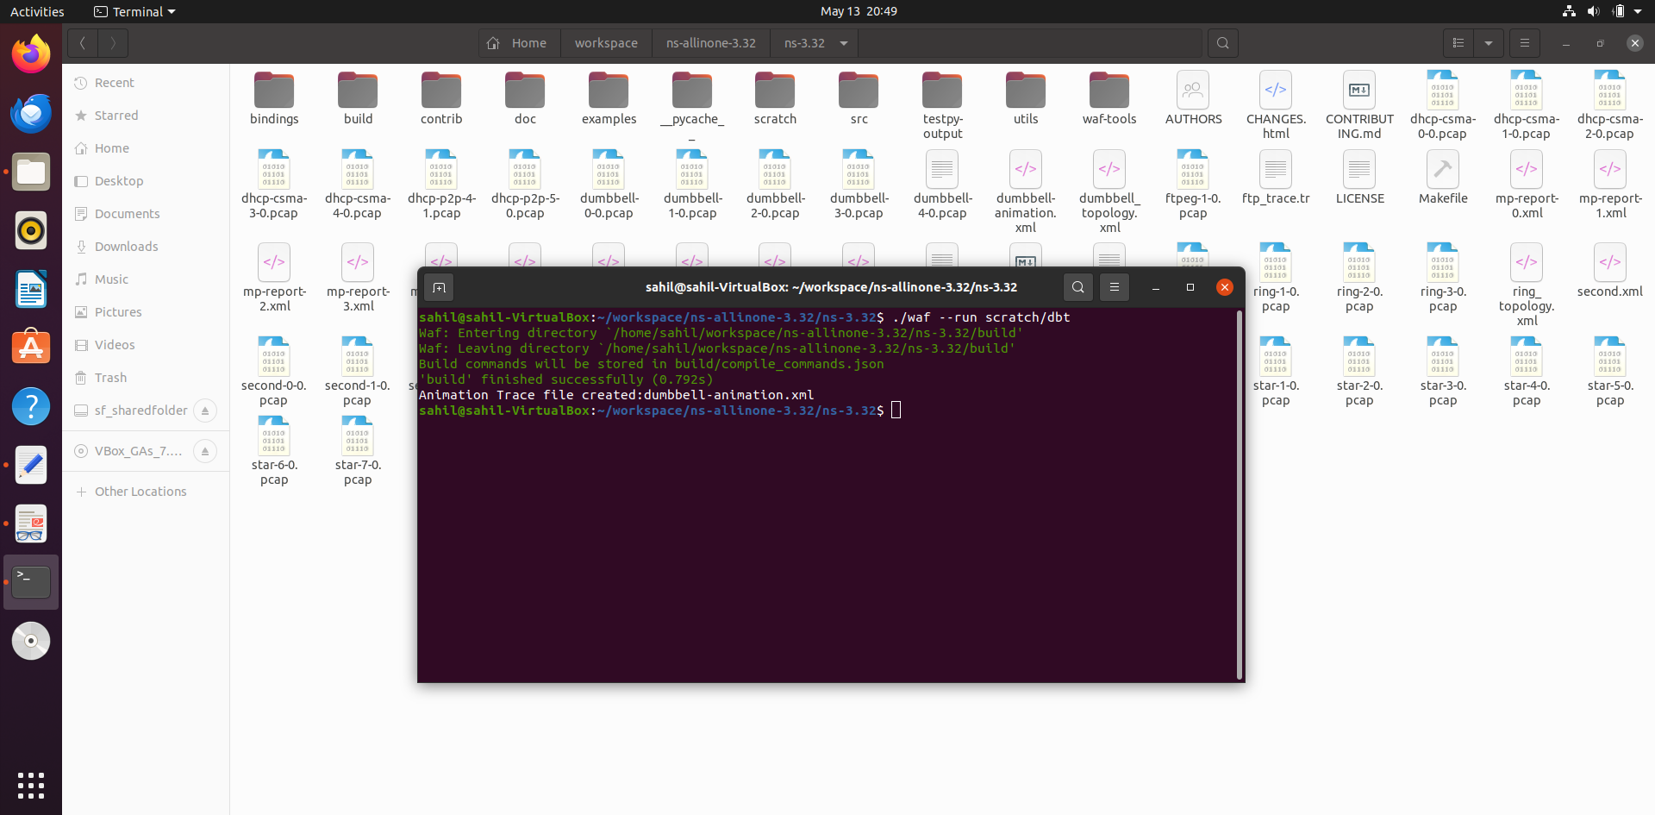

Visualize the Topology

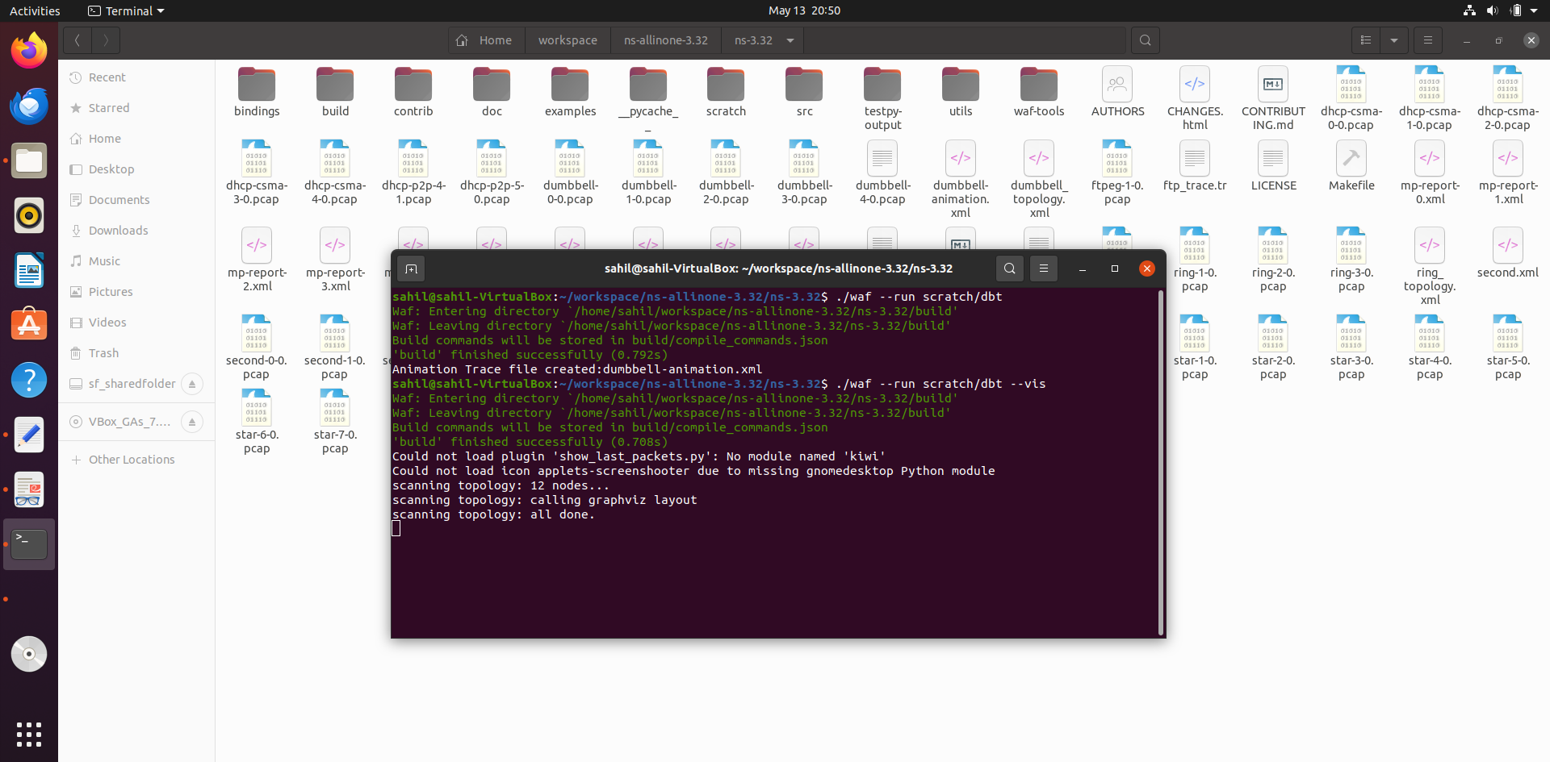

Before Simulation

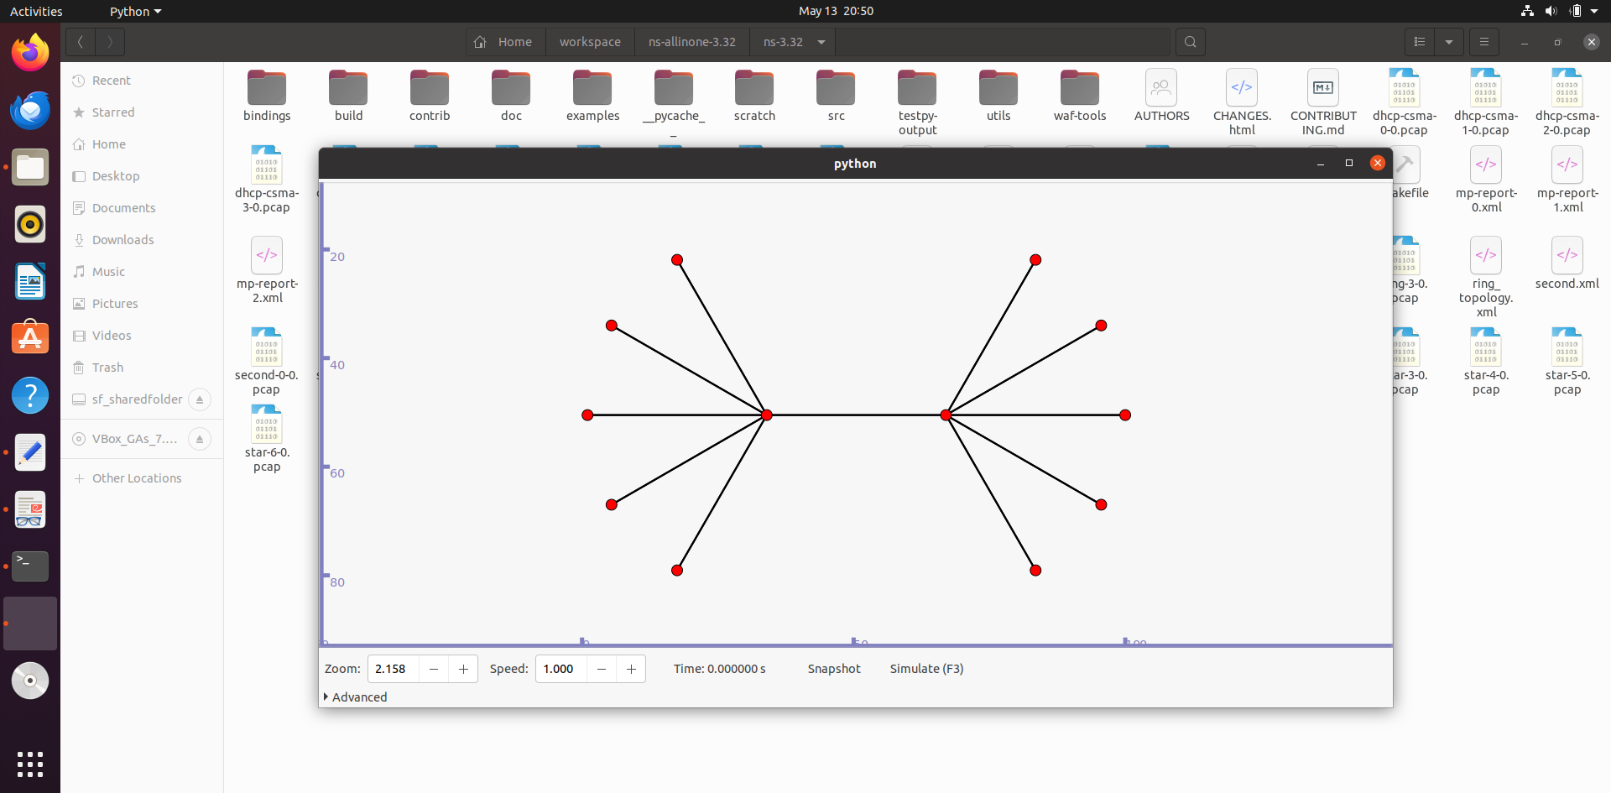

After Simulation

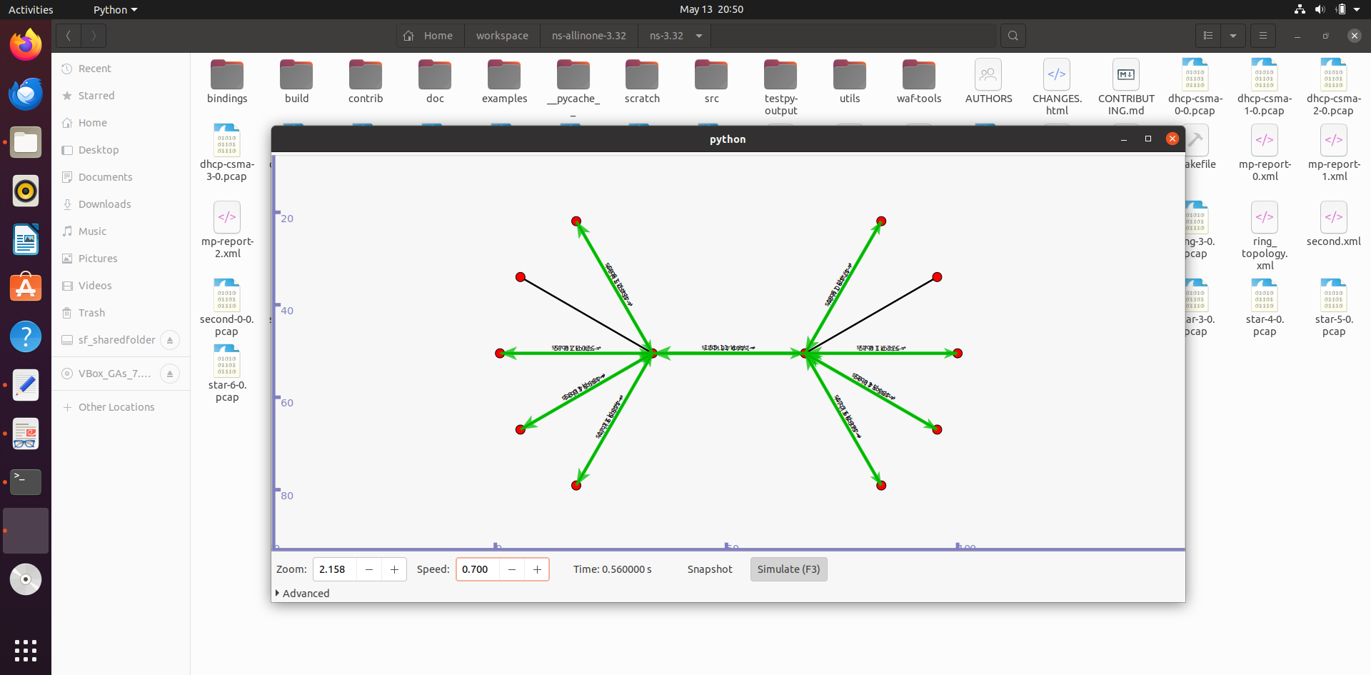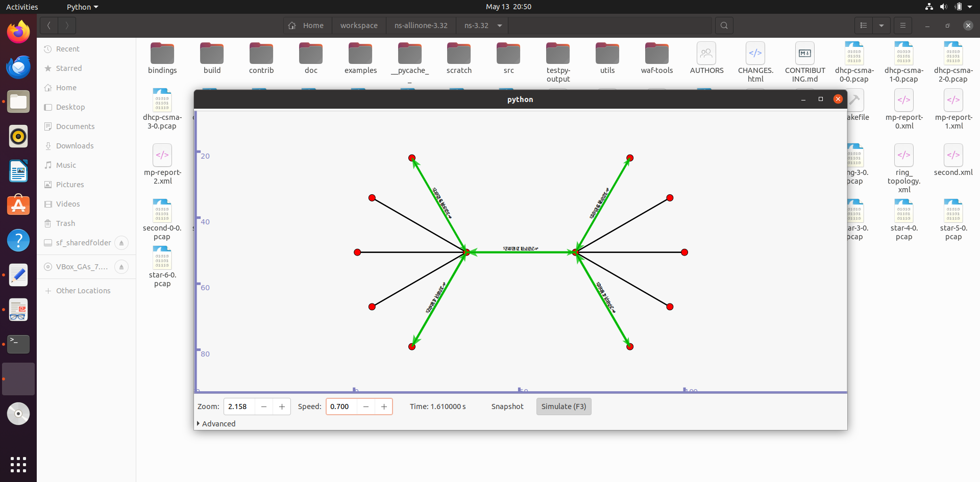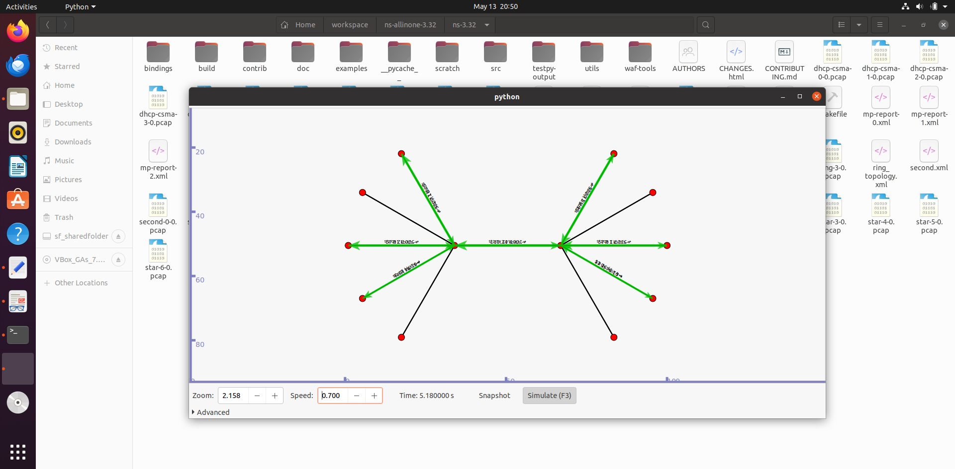

Simulation in NetAnim

